

**DEPARTMENT OF INFORMATION TECHNOLOGY LAB MANUAL**

**CS23432 – Software Construction**

**(REGULATION 2023)**

**RAJALAKSHMI ENGINEERING COLLEGE**

**Thandalam, Chennai-602015**

Name: Kavitha P

Register No: 231001087

Year / Branch / Section: 2nd/IT/ FA

Semester: IV

Academic Year: 2024 - 2025

INDEX

|  |  |  |
| --- | --- | --- |
| S.No. | Date | Title |
| 1. | 22/01/25 | Azure Devops Environment Setup. |
| 2. | 07/02/25 | Azure Devops Project Setup and User Story Management. |
| 3. | 14/02/25 | Setting Up Epics, Features, And User Stories for Project Planning. |
| 4. | 20/03/25 | Sprint Planning. |
| 5. | 28/03/25 | Poker Estimation. |
| 6. | 04/04/25 | Designing Class and Sequence Diagrams for Project Architecture. |
| 7. | 16/04/25 | Designing Architectural and ER Diagrams for Project Structure. |
| 8. | 18/04/25 | Testing – Test Plans and Test Cases. |
| 9. | 25/04/25 | Load Testing and Pipelines. |
| 10. | 02/05/25 | GitHub: Project Structure & Naming Conventions. |

|  |  |
| --- | --- |
| **Exp.No: 1** | **AZURE DEVOPS ENVIRONMENT SETUP** |
| **Date:22/01/2025** |

**AIM:** To set up and access the Azure DevOps environment by creating an organization through the Azure Portal.

**INSTALLATION**

1.Open your web browser and go to the Azure website:

https://azure.microsoft.com/en-us/getstarted/azure-portal.

Sign in using your Microsoft account credentials.

If you don't have a Microsoft account, you can create one here: https://signup.live.com/?lic=1 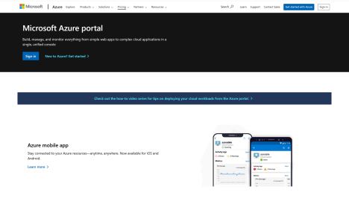

2.Azure home page

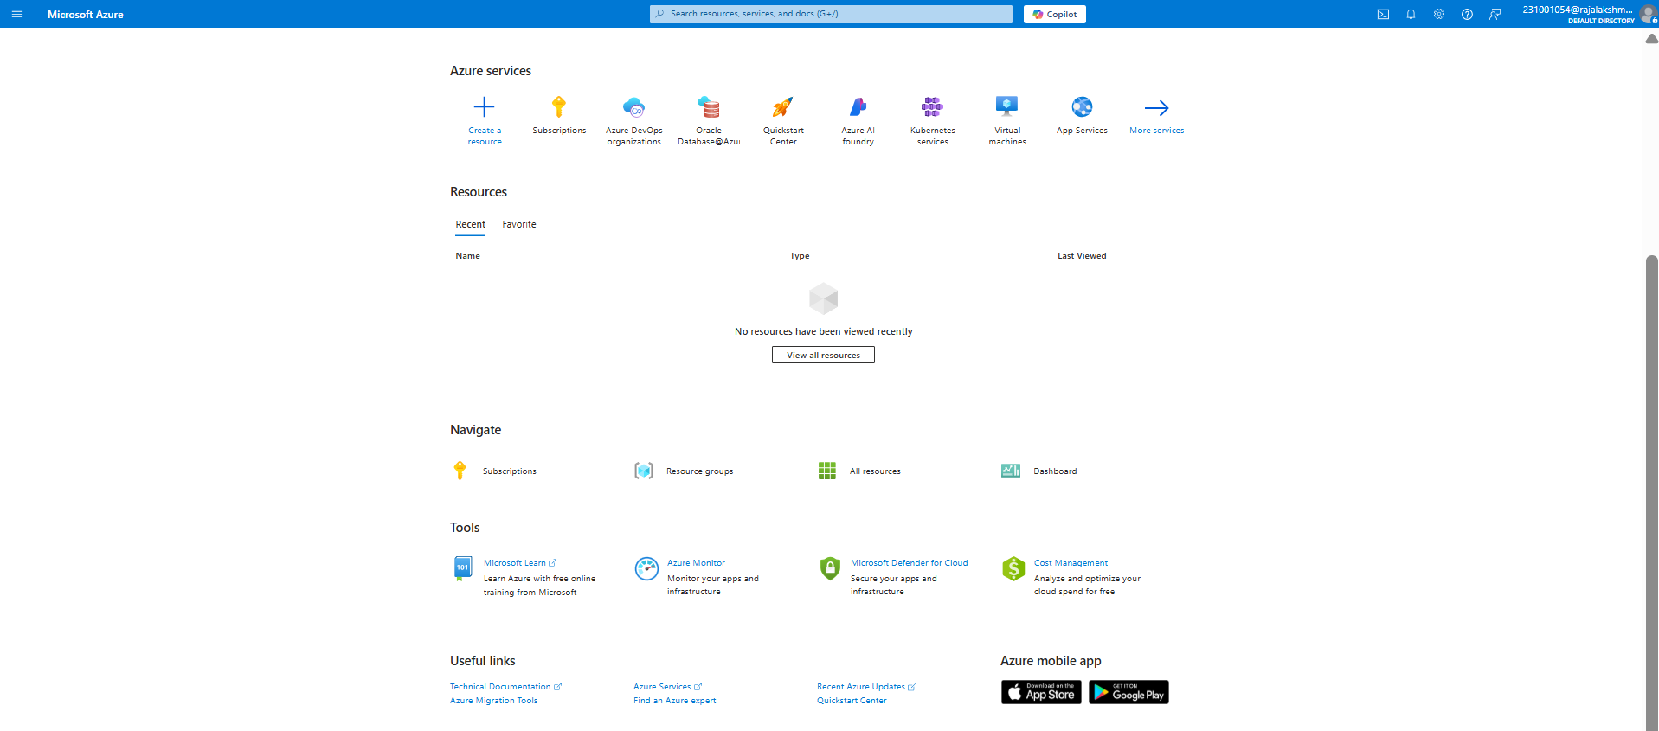

3.Open DevOps environment in the Azure platform by typing ***Azure DevOps Organizations*** in the search bar.

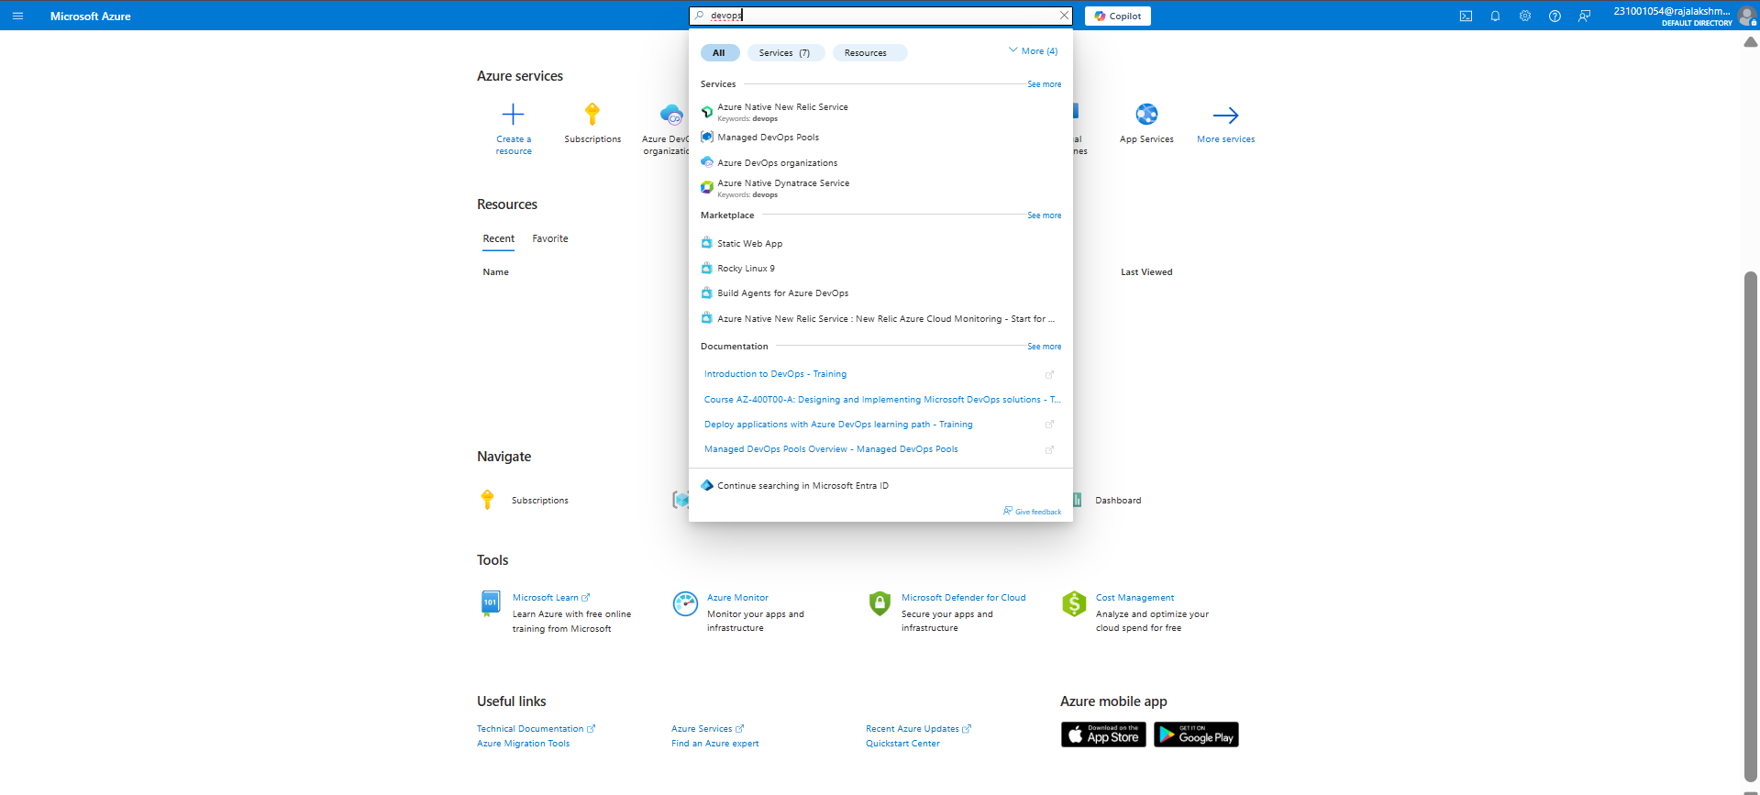

4.Click on the ***My Azure DevOps Organization*** link and create an organization and you should be taken to the Azure DevOps Organization Home page.

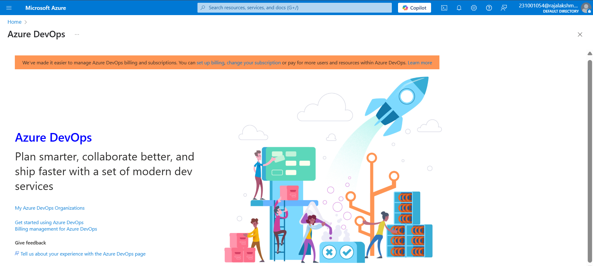

**RESULT:** Successfully accessed the Azure DevOps environment and created a new organization through the Azure portal.

|  |  |
| --- | --- |
| **Exp.No: 2** | **AZURE DEVOPS PROJECT SET UP AND USER STORY MANAGEMENT** |
| **Date: 07/02/2025** |

**AIM:** To set up an Azure DevOps project for efficient collaboration and agile work management.

**STEPS:**

1.Create An Azure Account

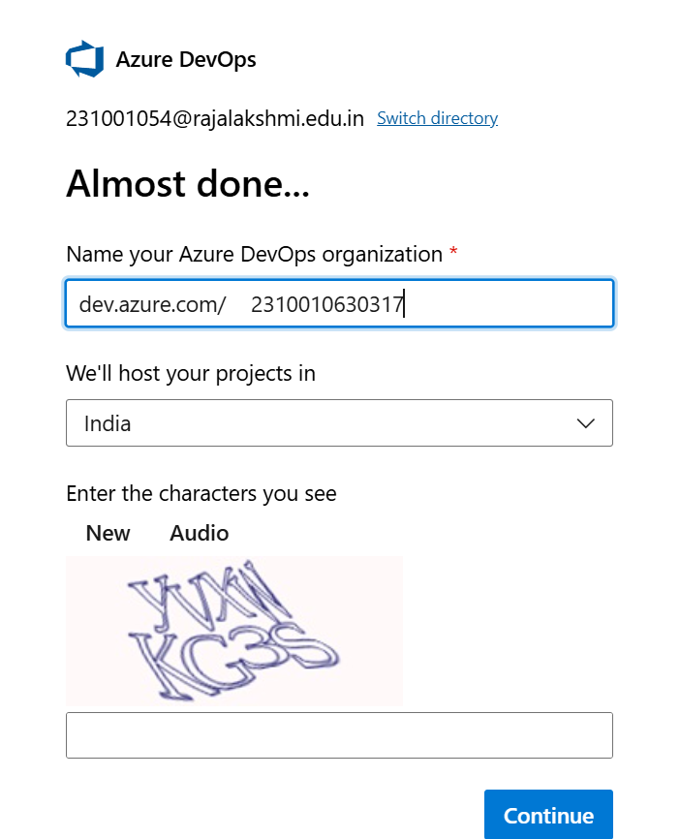

2.Create the First Project in Your Organization

a. After the organization is set up, you’ll need to create your first **project**. This is where you'll begin to manage code, pipelines, work items, and more.

b. On the organization’s **Home page**, click on the **New Project** button.

c. Enter the project name, description, and visibility options:

***Name****:* Choose a name for the project (e.g., LMS).

***Description****:* Optionally, add a description to provide more context about the project. ***Visibility****:* Choose whether you want the project to be **Private** (accessible only to those invited) or **Public** (accessible to anyone).

d. Once you’ve filled out the details, click **Create** to set up your first project.

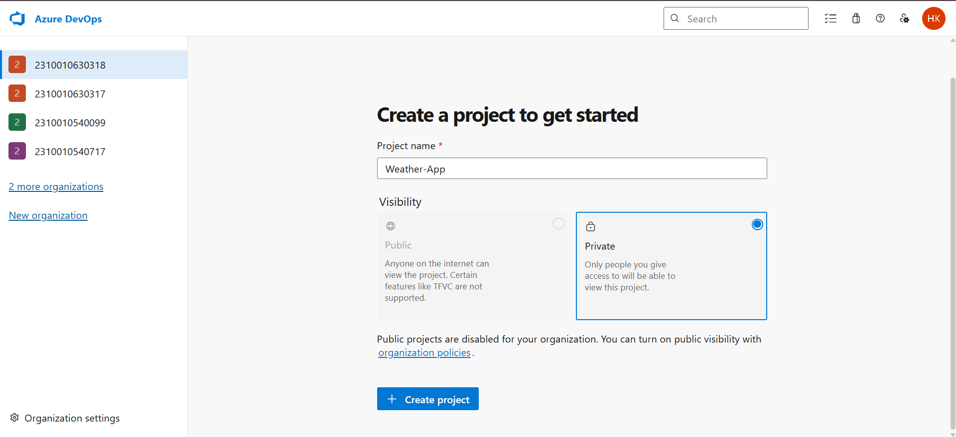

3.Once logged in, ensure you are in the correct organization. If you're part of multiple organizations, you can switch between them from the top left corner (next to your user profile). Click on the Organization name, and you should be taken to the Azure DevOps Organization Home page.

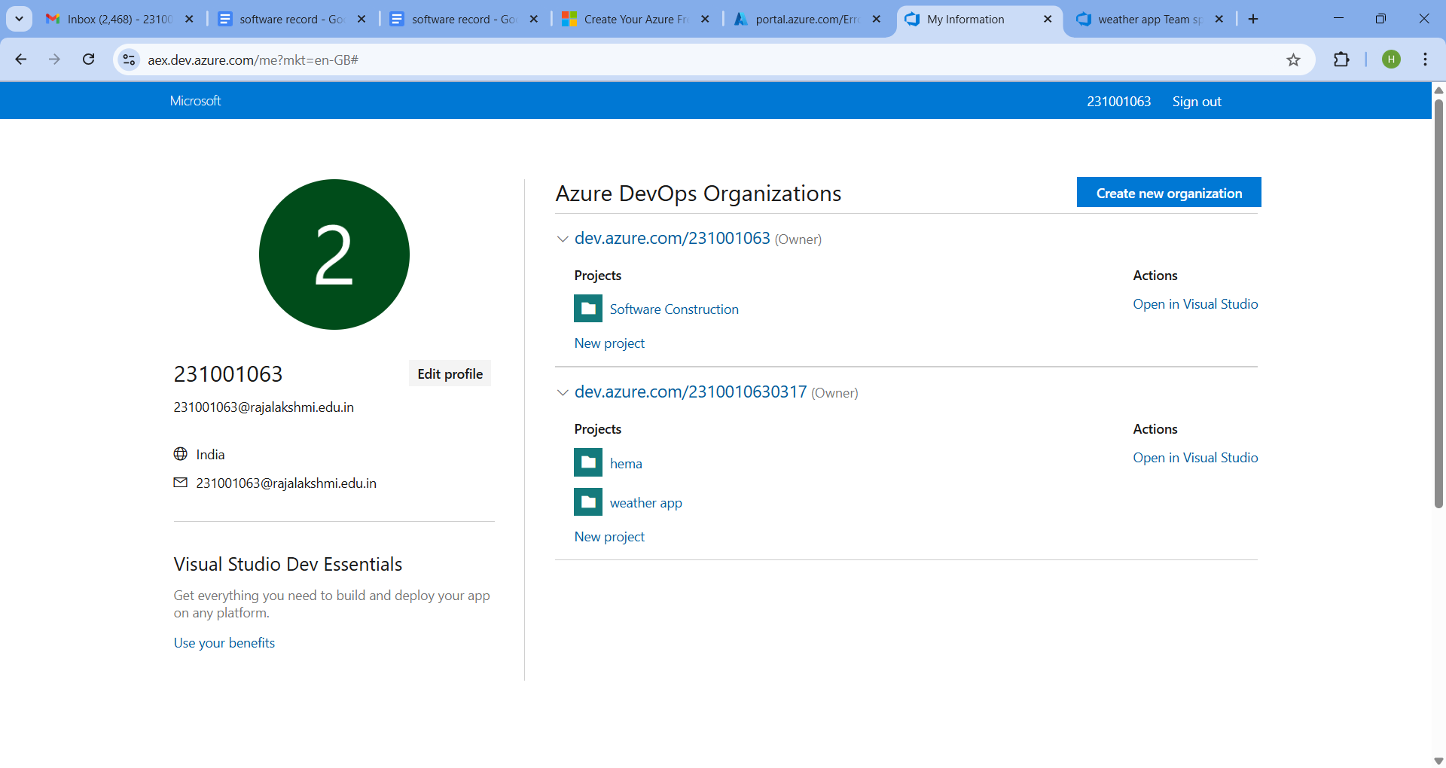

4.Project dashboard

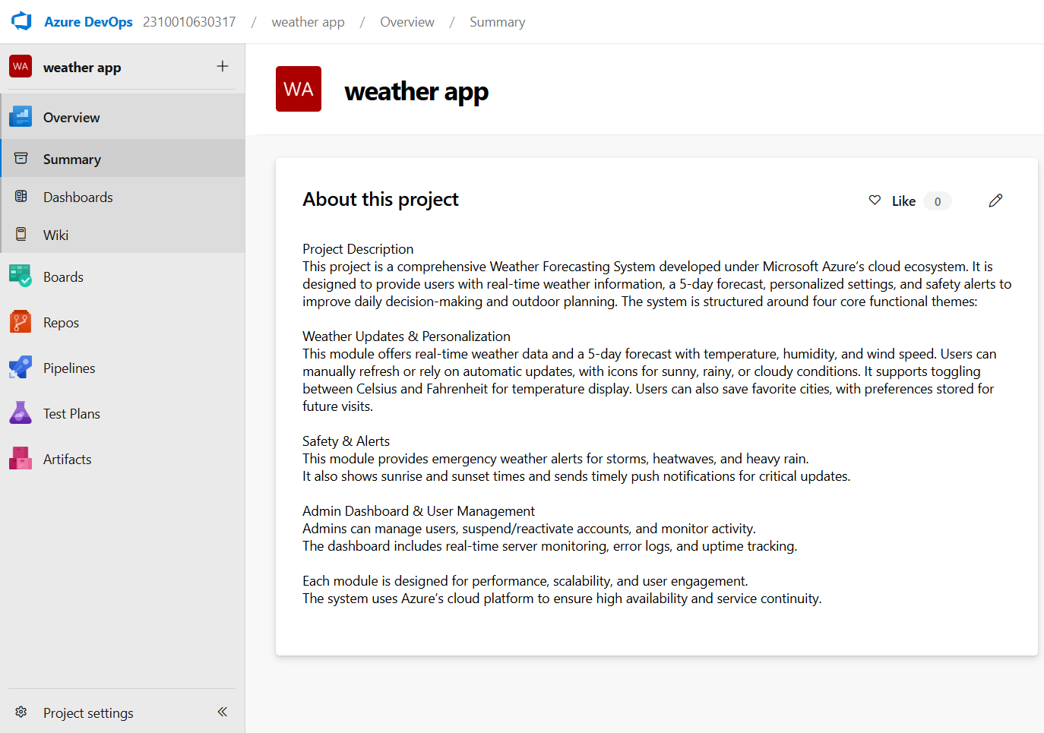

5.To manage user stories:

a. From the **left-hand navigation menu**, click on **Boards**. This will take you to the main **Boards** page, where you can manage work items, backlogs, and sprints.

b. On the **work items** page, you'll see the option to **Add a work item** at the top. Alternatively, you can find a **+** button or **Add New Work Item** depending on the view you're in. From the **Add a work item** dropdown, select **User Story**. This will open a form to enter details for this user story.

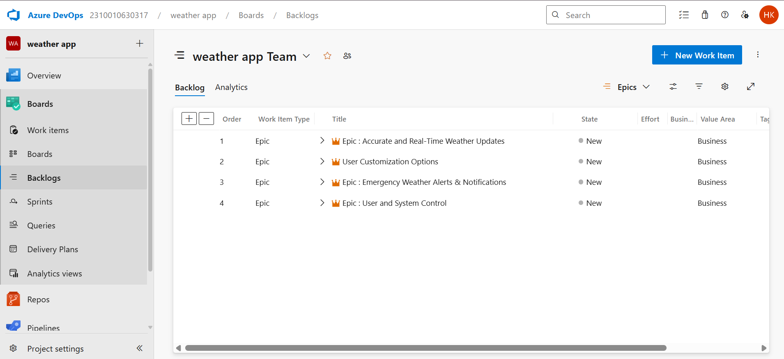

**RESULT:** Successfully created an Azure DevOps project with user story management and agile workflow setup.

|  |  |
| --- | --- |
| **Exp.No: 3** | **SETTING UP EPICS FEATURES AND USER STORIES FOR PROJECT PLANNING** |
| **Date: 14/02/2025** |

**AIM:** To learn about how to create epics, user story, features, backlogs for your assigned project.

**1.Fill in Epics**

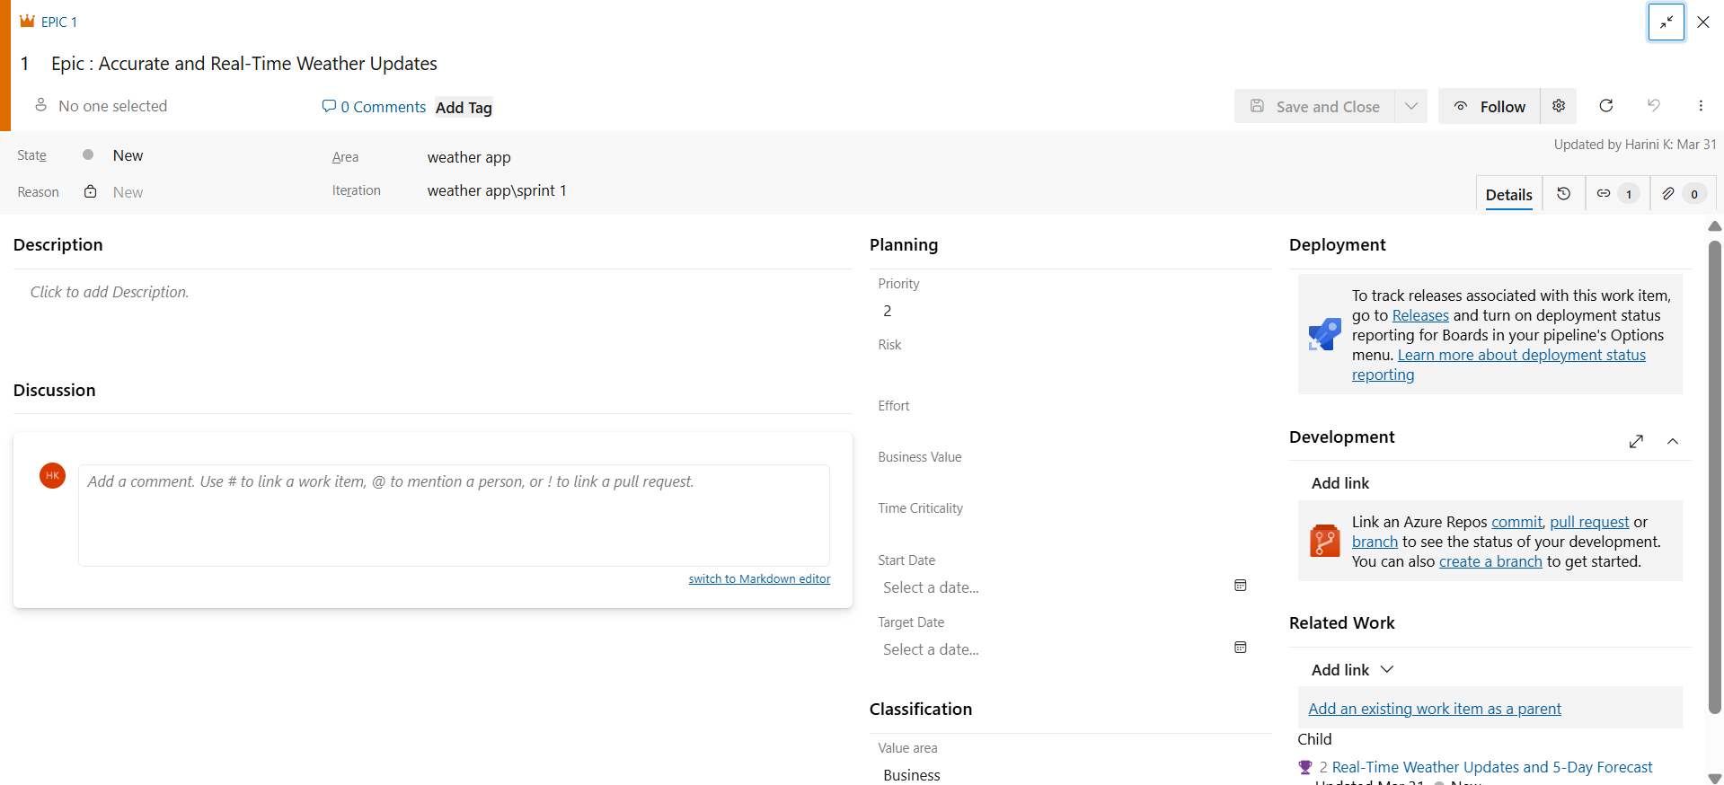

**2.Fill in Features**

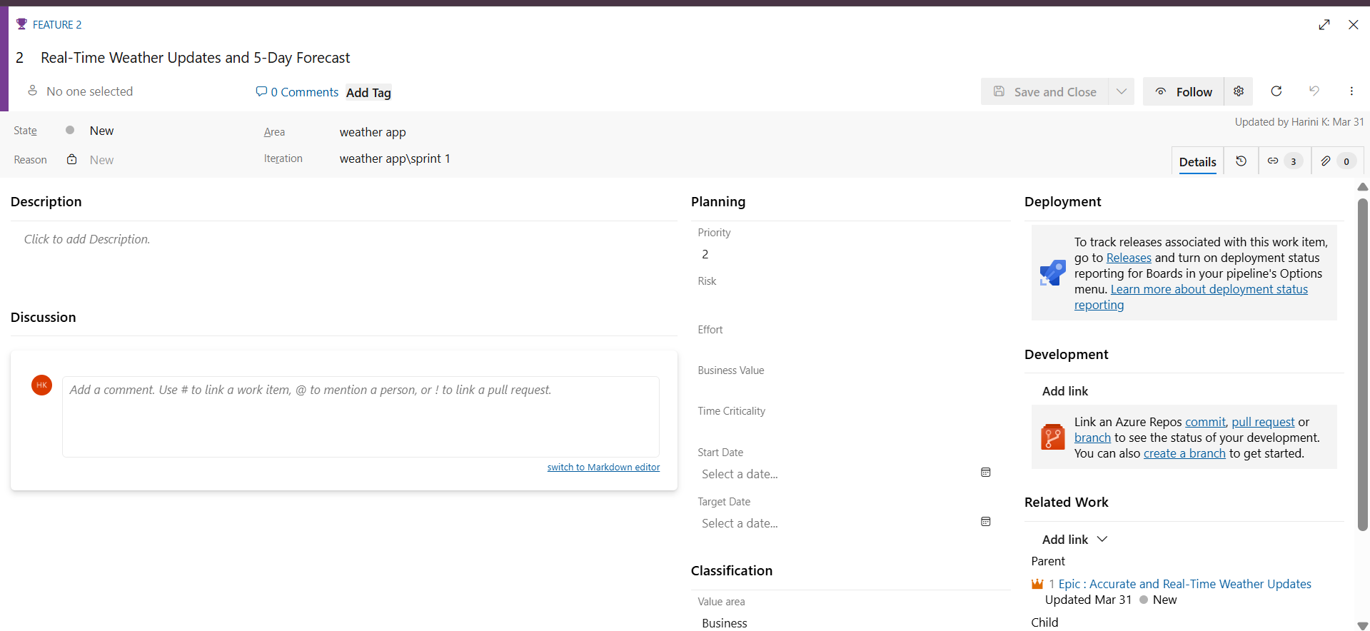

**3.Fill in User Story Details**

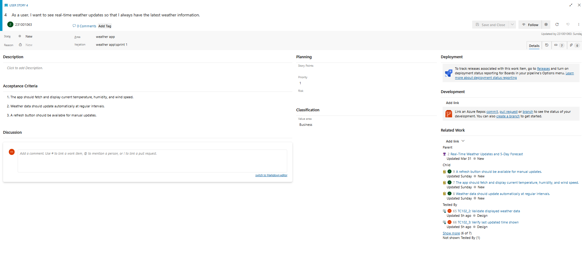

**4.Fill in Task Details**

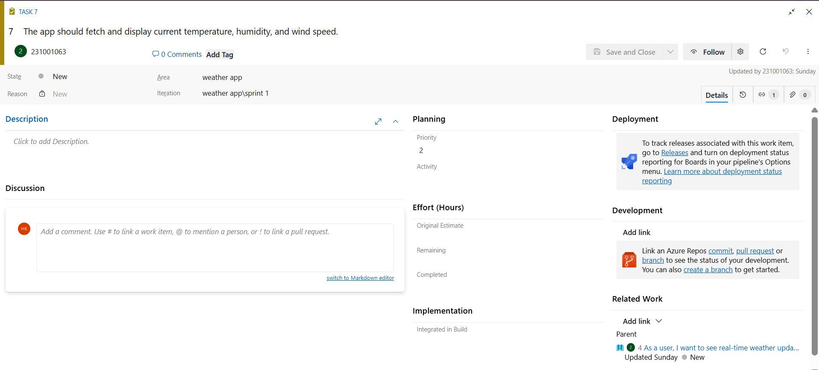

**RESULT:** Thus, the creation of epics, features, user story and task has been created successfully.

|  |  |
| --- | --- |
| **Exp.No: 4** | **SPRINT PLANNING** |
| **Date: 20/03/2025** |

**AIM:** To assign user story to specific sprint for the Weather App Project.

**SPRINT PLANNING**

**Sprint 1**

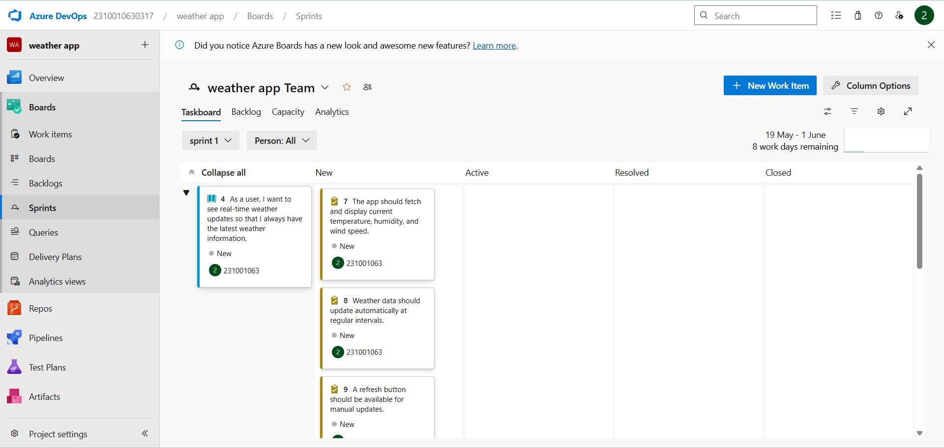

**Sprint 2**

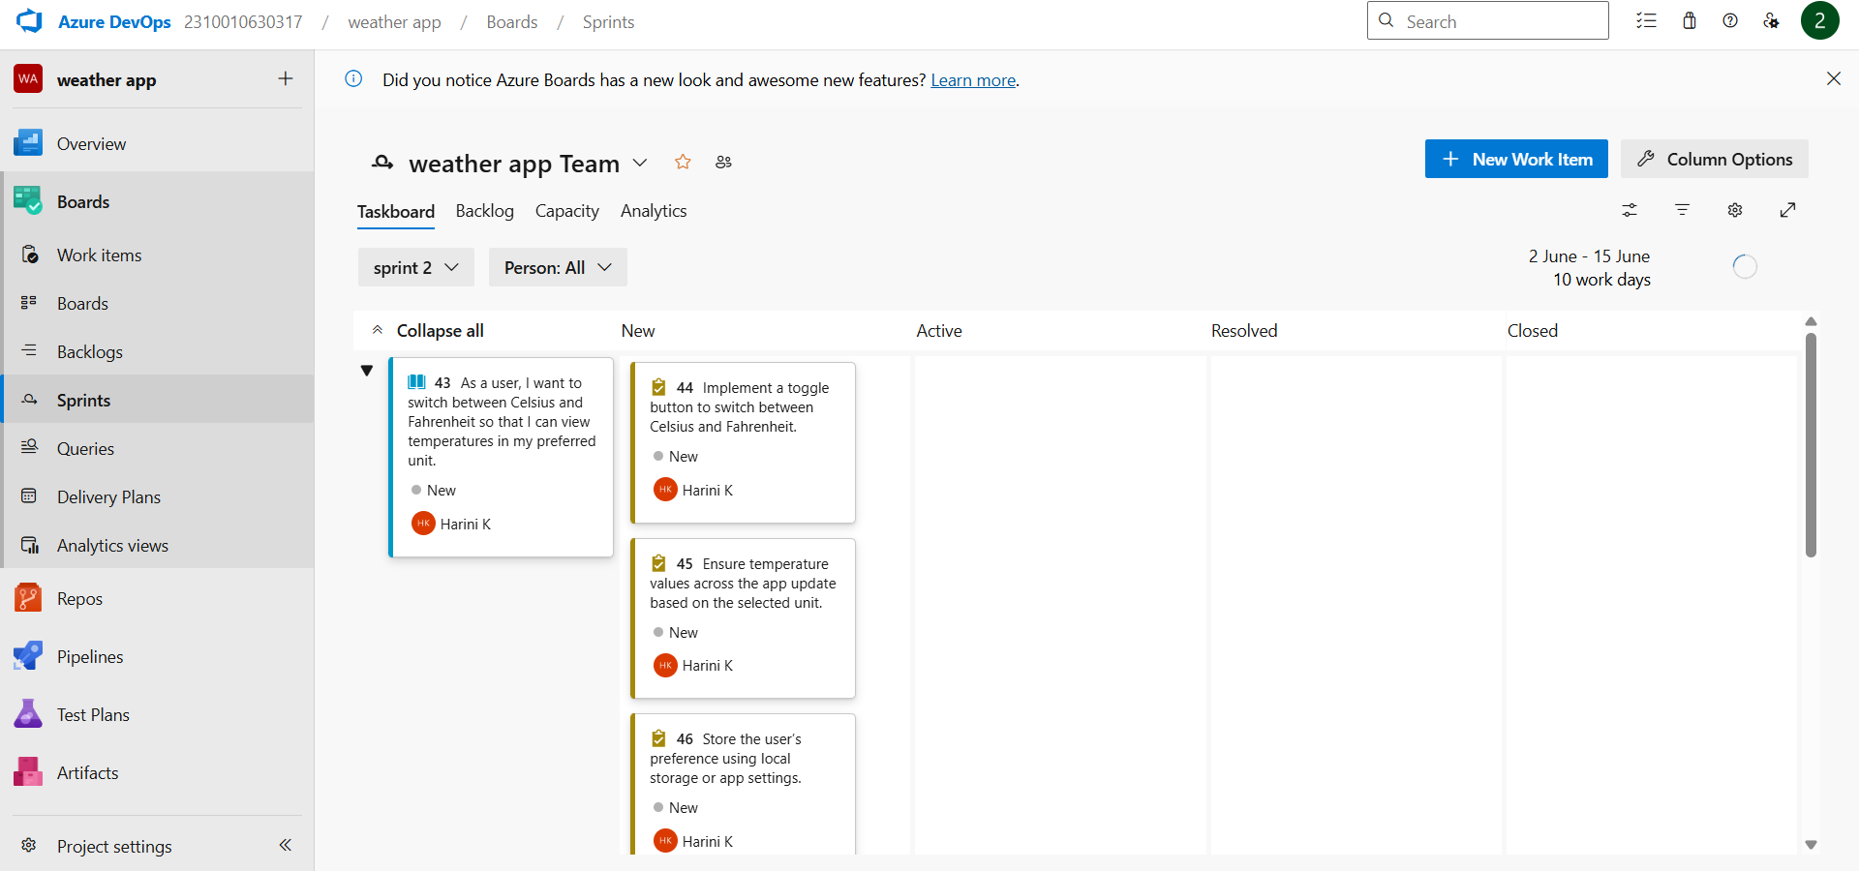

**Sprint 3**

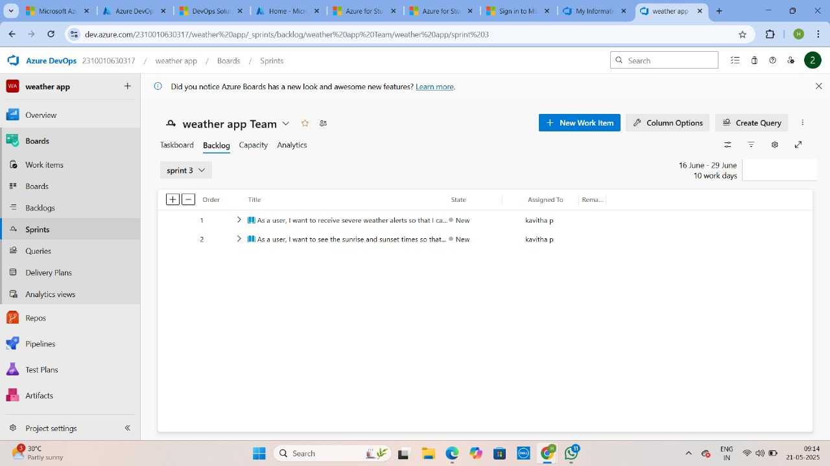

**Sprint 4**

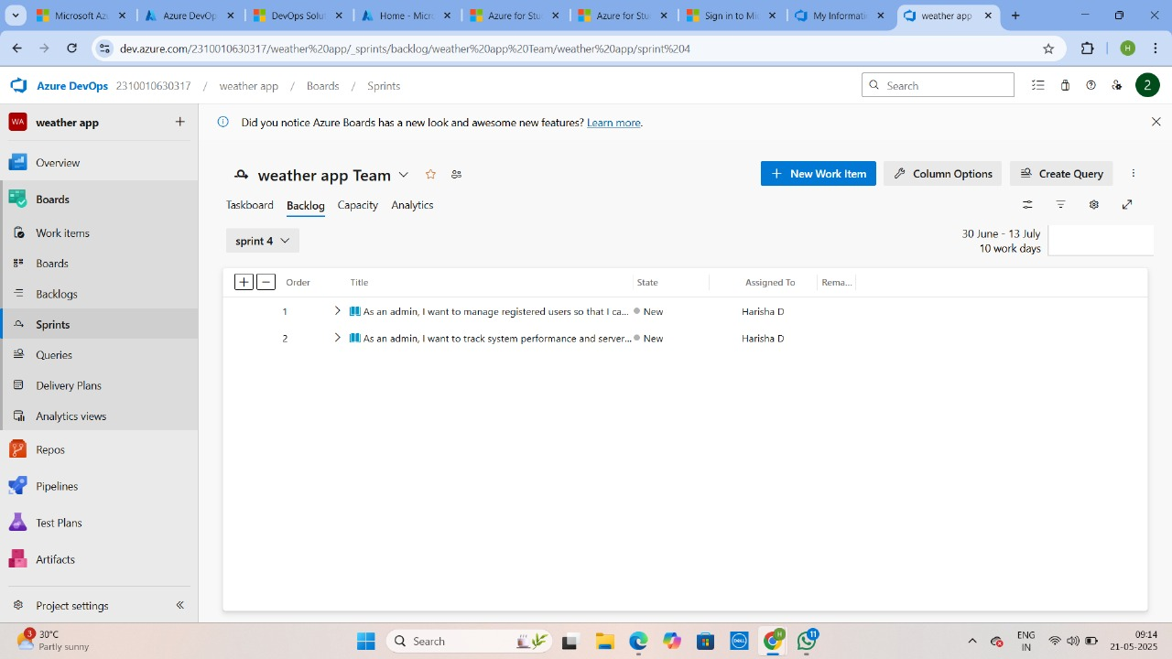

**RESULT:** The Sprints are created for the Weather App Project.

|  |  |
| --- | --- |
| **Exp.No: 5** | **POKER ESTIMATION** |
| **Date: 28/03/2025** |

**AIM:** Create Poker Estimation for the user stories - Weather App Project. **POKER ESTIMATION**

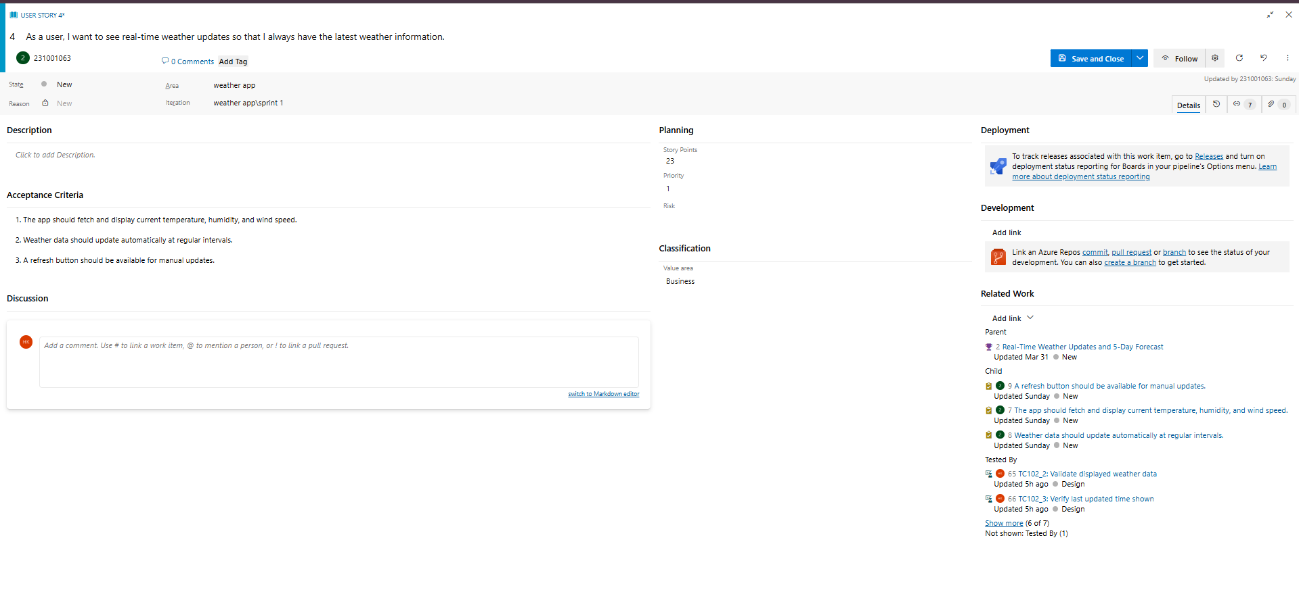

**RESULT:** The Estimation/Story Points is created for the project using Poker Estimation.

|  |  |
| --- | --- |
| **Exp.No: 6** | **DESIGNING CLASS AND SEQUENCE DIAGRAMS FOR PROJECT ARCHITECTURE** |
| **Date: 04/04/2025** |

**AIM:** To Design a Class Diagram and Sequence Diagram for the given Project.

**6A. CLASS DIAGRAM**

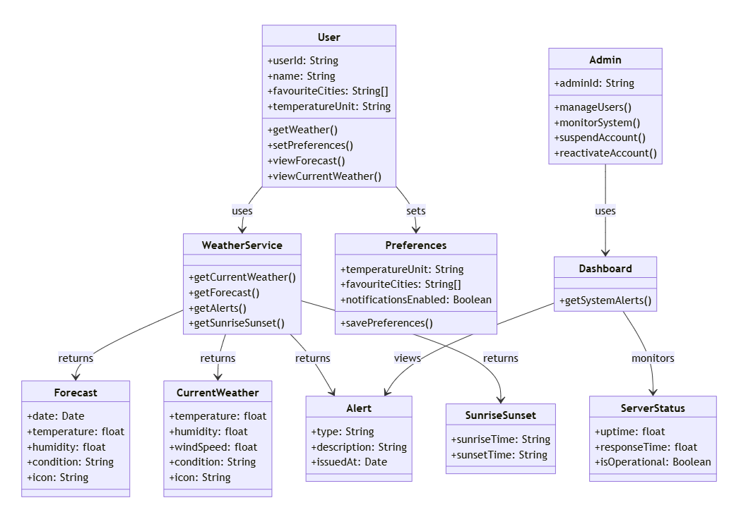

**6B. SEQUENCE DIAGRAM**

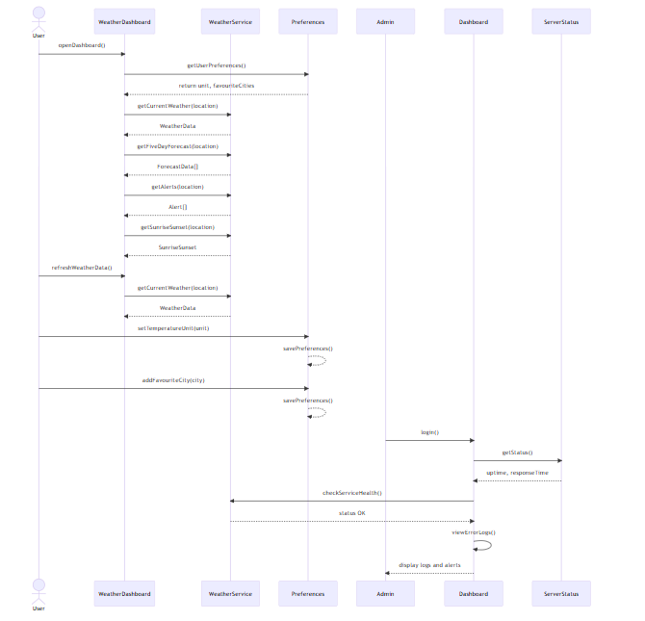

**RESULT:** The Class Diagram and Sequence Diagram is designed Successfully for the Weather App

|  |  |
| --- | --- |
| **Exp.No: 7** | **DESIGNING ARCHITECTURAL AND ER DIAGRAMS FOR PROJECT STRUCTURE** |
| **Date: 16/04/2025** |

**AIM:** To Design an Architectural Diagram and ER Diagram for the given Project. **7A. ARCHITECTURAL DIAGRAM**

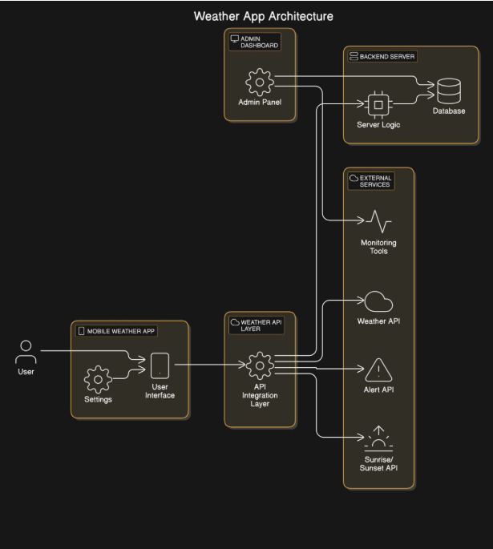

**7B. ER DIAGRAM**

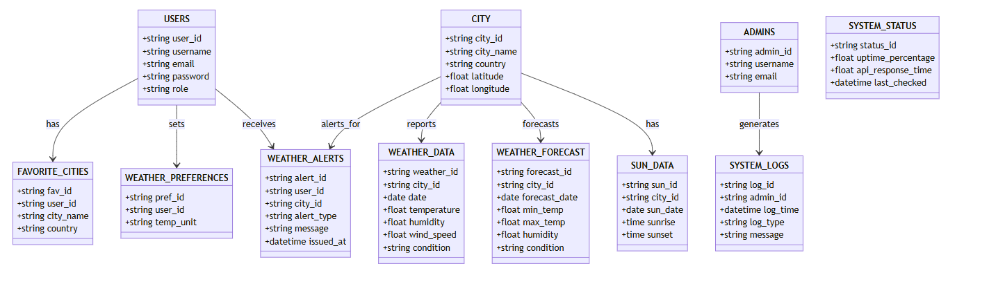

**RESULT:** The Architecture Diagram and ER Diagram is designed Successfully for the Online Banking System.

|  |  |
| --- | --- |
| **Exp.No: 8** | **TESTING-TEST PLANS AND TEST CASES** |
| **Date: 18/04/2025** |

**AIM:** Test Plans and Test Case and write two test cases for at least five user stories showcasing the happy path and error scenarios in azure DevOps platform.

**TEST PLANNING AND TEST CASE**

**Test Case Design Procedure**

1. Understand Core Features of the Application

● Real-Time Weather Updates (Current temperature, humidity, wind speed)

● 5-Day Weather Forecast (Daily conditions, temperature trends, icons)

● Emergency Weather Alerts (Storms, heatwaves, heavy rain notifications)

● Sunrise & Sunset Information (Based on selected city and date)

● Admin Dashboard (User management, system monitoring, API uptime)

2. Define User Interactions

Each test case reflects realistic user actions:

● Viewing real-time weather for a selected city

● Checking the 5-day weather forecast

● Switching between Celsius and Fahrenheit temperature units

● Receiving emergency weather alerts and notifications

● Viewing sunrise and sunset times for better daily planning

● Admin managing users and monitoring system status

3. Design Happy Path Test Cases

● Focused on successful flows where inputs are valid and systems behave as expected. ● Examples:

○ User views current weather for a selected city

○ User successfully switches temperature units

○ 5-day forecast displays accurate and updated data

4. Design Error Path Test Cases

● Focused on handling invalid, missing, or unexpected inputs.

● Examples:

○ Weather data fails to load due to no internet connection

○ API error returns blank forecast data

○ User tries to add a duplicate city to favourites

5. Break Down Steps and Expected Results

Each test case includes:

● Clear step-by-step user actions (e.g., selecting a city, clicking refresh)

● Specific expected outcomes for each action (e.g., weather data updates, alert is triggered)

This ensures reproducibility and easy automation later.

6. Use Clear Naming and IDs

● Example:

○ TC01 – View Real-Time Weather Successfully

○ TC04 – Toggle Temperature Unit to Fahrenheit

○ TC08 – Alert Not Displayed (No Severe Weather)

● Helps trace test cases to user stories and features in Azure DevOps

7. Separate Test Suites

Organize test cases based on functional modules:

● TS01 – Real-Time Weather & Forecast

● TS02 – Temperature Unit Toggle & Preferences

● TS03 – Favourite Cities Management

● TS04 – Emergency Alerts & Notifications

● TS05 – Sunrise/Sunset Info & UI Display

● TS06 – Admin Dashboard & System Monitoring

**1.New test plan**

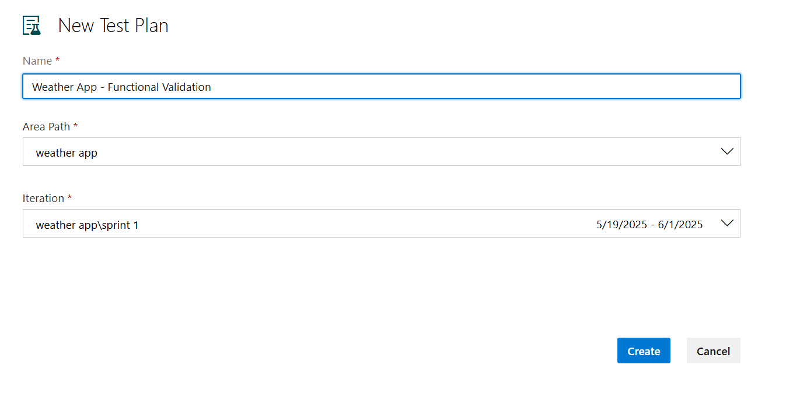

**2.Test suite**

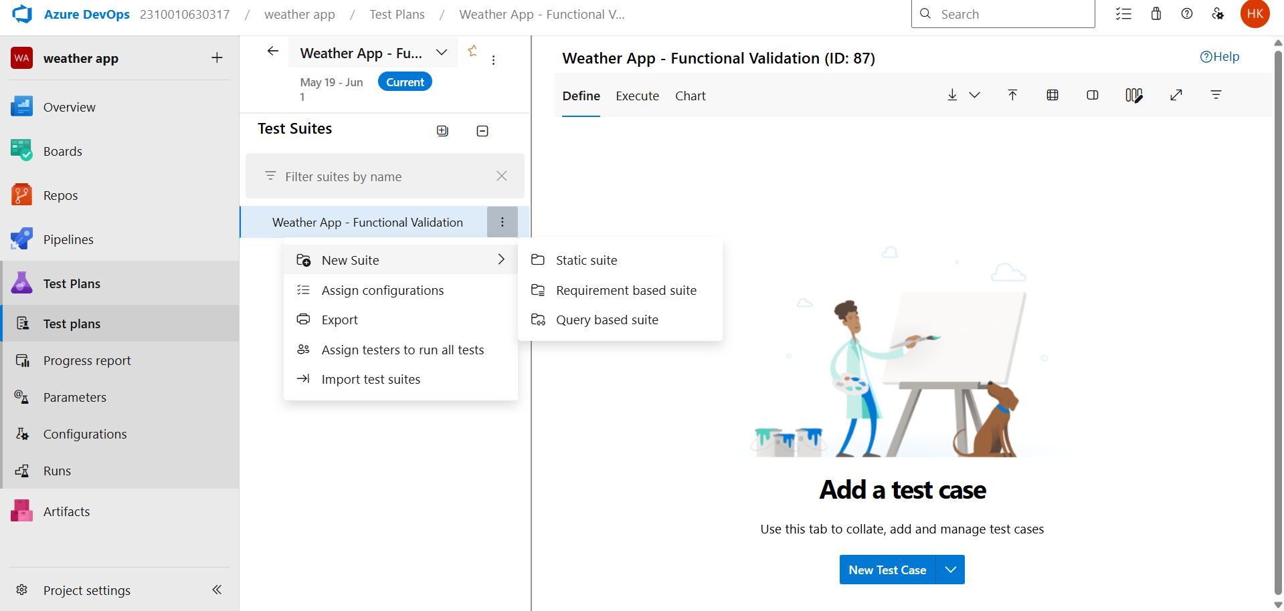

**3.Test case**

Give two test cases for at least five user stories showcasing the happy path and error scenarios in azure DevOps platform.

Weather App– Test Plans

**User Stories – Weather Application**

● **US199**:As a user, I want to see real-time weather updates so that I always have the latest weather information.

● **US200**:As a user, I want to view a 5-day weather forecast so that I can plan my activities in advance.

● **US196**: As an admin, I want to manage registered users so that I can monitor app usage and ensure compliance with policies.

● **US198**: As a user, I want to receive severe weather alerts so that I can take precautions.

● **US201**: As a user, I want to switch between Celsius and Fahrenheit so that I can view temperatures in my preferred unit

**TEST SUITE: TC301_1- RECEIVE ALERT FOR STORM (ID:57)**

**Test Case:TC301_1: Receive alert for storm during disasters**

**User Story**: As a user, I want to receive severe weather alerts so that I can take necessary precautions.

**Test Type**: Happy Path

**Steps and Expected Results:**

* **Action:** Enable storm alerts in settings  
   **Expected Result:** Setting is saved successfully
* **Action:** Trigger storm alert from system  
   **Expected Result:** Alert is activated
* **Action:** Send alert to user via preferred method  
   **Expected Result:** User receives storm alert notification

**Notes:** Ensure user's contact info is valid. This test checks successful alert delivery.

**TEST SUITE: TC301_1- GET PUSH NOTIFICATION (ID:57)**

**Test Case: TC301_2: Get push notification by the user**

**User Story**: As a user, I want to receive severe weather alerts so that I can take necessary precautions.

**Test Type**: Error Path

**Steps and Expected Results:**

* **Action:** Enable push notifications for weather alerts  
   **Expected Result:** Setting is saved successfully
* **Action:** Disable app notification permissions from device settings  
   **Expected Result:** App no longer has permission to send push notifications
* **Action:** Trigger a severe weather alert  
   **Expected Result:** User does not receive the push notification

**Notes:** Validates graceful handling of blocked notifications with a fallback or log entry.

**TEST SUITE: TC202_1: OPEN SYSTEM DASHBOARD (ID:56)**

**Test Case: TC202_1: Open system dashboard by admin.**

**User Story**: As an admin, I want to track system performance and server status so that I can ensure smooth app functionality.

**Test Type**: Happy Path

**Steps and Expected Results:**

* **Action:** Navigate to the login page  
   **Expected Result:** Login page is displayed
* **Action:** Enter valid admin username and password  
   **Expected Result:** Credentials are accepted with no errors
* **Action:** Click the "Login" button  
   **Expected Result:** Admin is redirected to the system dashboard

**Notes:**Ensure the test user has admin privileges. This test confirms successful access to the dashboard under normal conditions.

**Test Case: TC301_3: No alert when clear weather**

**User Story**:As a user, I want to receive severe weather alerts so that I can take necessary precautions.

**Test Type**: Error Path

**Steps and Expected Results:**

**● Action:** Enable severe weather alerts in user settings  
 **Expected Result:** Setting is saved successfully

**● Action:** Simulate or confirm clear weather conditions  
 **Expected Result:** No alert is triggered by the system

**● Action:** Monitor user's device for notifications  
 **Expected Result:** No alert or notification is received

**TEST SUITE: TC102_3: Verify last updated time shown (ID:54)**

**Test Case: TC102_3: Verifies the last updated time shown**

**User Story**: As a user, I want to see real-time weather updates so that I always have the latest weather information.

**Test Type**: Happy Path

**Steps and Expected Results:**

* **Action:** Open the weather application/dashboard  
   **Expected Result:** Weather data is displayed along with the "Last Updated" timestamp
* **Action:** Wait for a scheduled weather data refresh **Expected Result:** "Last Updated" time updates to reflect the most recent fetch
* **Action:** Compare displayed time with system/server time **Expected Result:** Timestamp accurately reflects the latest data update

**TEST SUITE: TC102_2- Validate displayed weather data (ID:54)**

**Test Case: TC102_2- Validate displayed weather data**

**User Story**: As a user, I want to see real-time weather updates so that I always have the latest weather information.

**Test Type**: Error Path

**Steps and Expected Results:**

* **Action:** Disconnect the device from the internet  
   **Expected Result:** App fails to fetch latest weather data
* **Action:** Open the weather application/dashboard  
   **Expected Result:** An error message like “Unable to retrieve data” is shown
* **Action:** Check displayed weather information  
   **Expected Result:** Outdated data is shown with a warning or timestamp indicating it's not current

**TEST SUITE: TC201– DELETE A USER (ID: 55)**

**Test Case: TC201 – Deleting a user**

**User Story**:As an admin, I want to manage registered users so that I can monitor app

usage and ensure compliance with policies.

**Test Type**: Happy Path

**Steps and Expected Results:**

* **Action:** Log in with valid admin credentials  
   **Expected Result:** Admin is redirected to the admin dashboard
* **Action:** Navigate to the "User Management" section  
   **Expected Result:** List of registered users is displayed
* **Action:** Select a user and click the "Delete" button  
   **Expected Result:** Confirmation prompt appears
* **Action:** Confirm the deletion  
   **Expected Result:** User is removed from the system and a success message is displayed

**TEST SUITE: TC201_3 - INVALID USER DELETE ATTEMPT (ID:55)**

**Test Case:TC201_3 - invalid user delete attempt**

**User Story**: As an admin, I want to manage registered users so that I can monitor app usage and ensure compliance with policies.

**Test Type**: Error Path

**Steps and Expected Results:**

* **Action:** Log in with valid admin credentials  
   **Expected Result:** Admin is redirected to the admin dashboard
* **Action:** Navigate to the "User Management" section  
   **Expected Result:** List of registered users is displayed
* **Action:** Attempt to delete a non-existent or already deleted user  
   **Expected Result:** Error message is shown (e.g., “User not found” or “Unable to delete user”)

**TEST SUITE: TC102_1: CHECK UPDATE REFRESH INTERVAL (ID:54)**

**Test Case: Check update refresh interval**

**User Story**: As a user, I want to see real-time weather updates so that I always have the latest weather information.

**Test Type**: Happy Path

**Steps and Expected Results:**

* **Action:** Open the weather application/dashboard  
   **Expected Result:** Weather data is displayed with a visible "Last Updated" timestamp
* **Action:** Wait for the predefined refresh interval (e.g., 10 minutes) **Expected Result:** Weather data is refreshed automatically without manual action
* **Action:** Verify that the "Last Updated" timestamp has changed  
   **Expected Result:** Timestamp reflects the new update time, confirming automatic refresh

**TEST SUITE: TC102_2: Validate displayed weather data (ID:54)**

**Test Case: Validate displayed weather data**

**User Story**:As a user, I want to see real-time weather updates so that I always have the latest weather information.

**Test Type**: Error Path

**Steps and Expected Results:**

* **Action:** Disconnect the device from the internet  
   **Expected Result:** Network connection is lost
* **Action:** Open the weather application/dashboard  
   **Expected Result:** Weather data fails to update
* **Action:** Observe the displayed weather information  
   **Expected Result:** App shows an error message (e.g., “No internet connection”) and displays previously cached data with an outdated timestamp

**Test Cases**

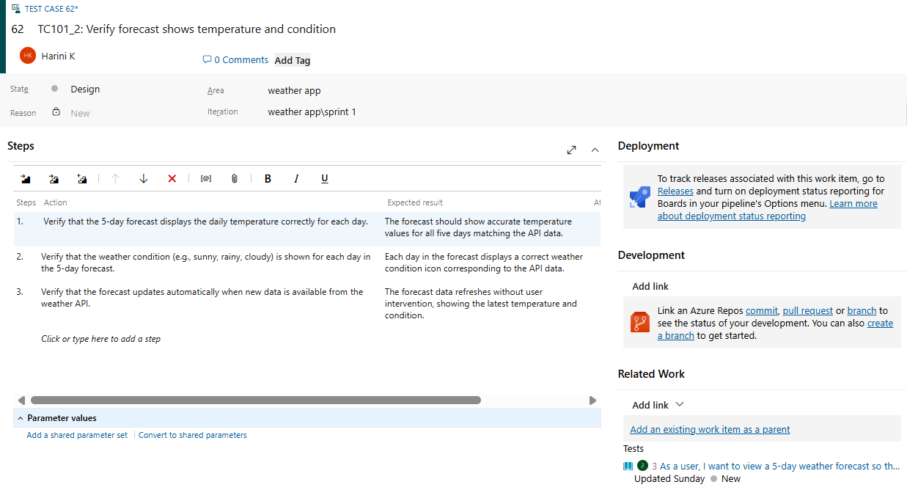

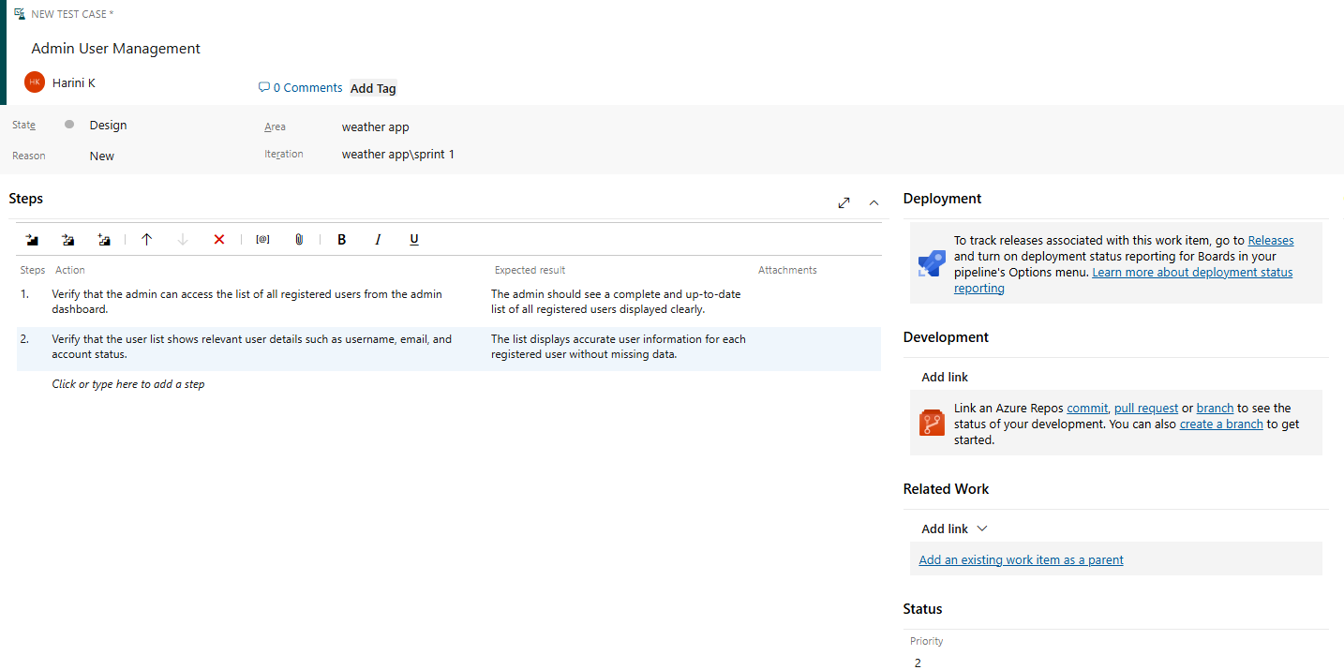

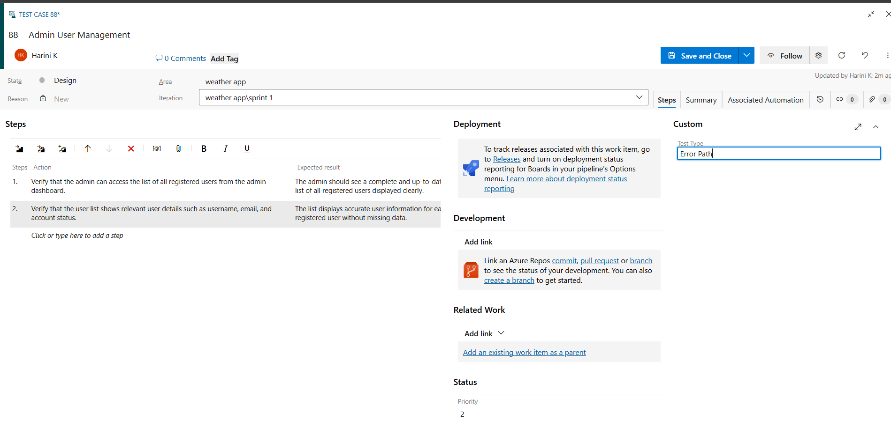

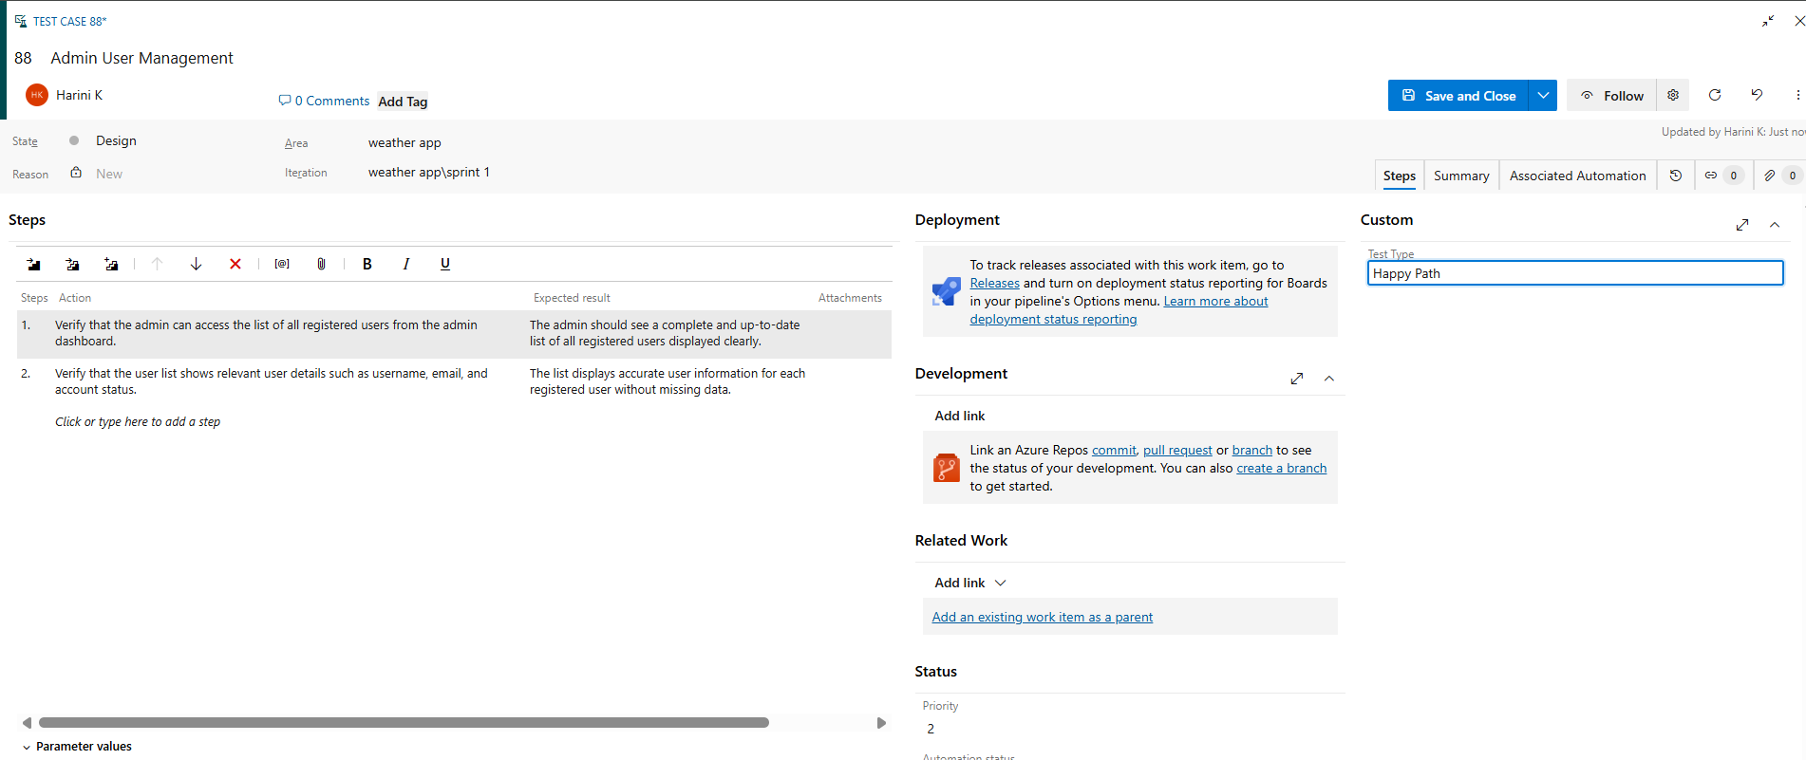

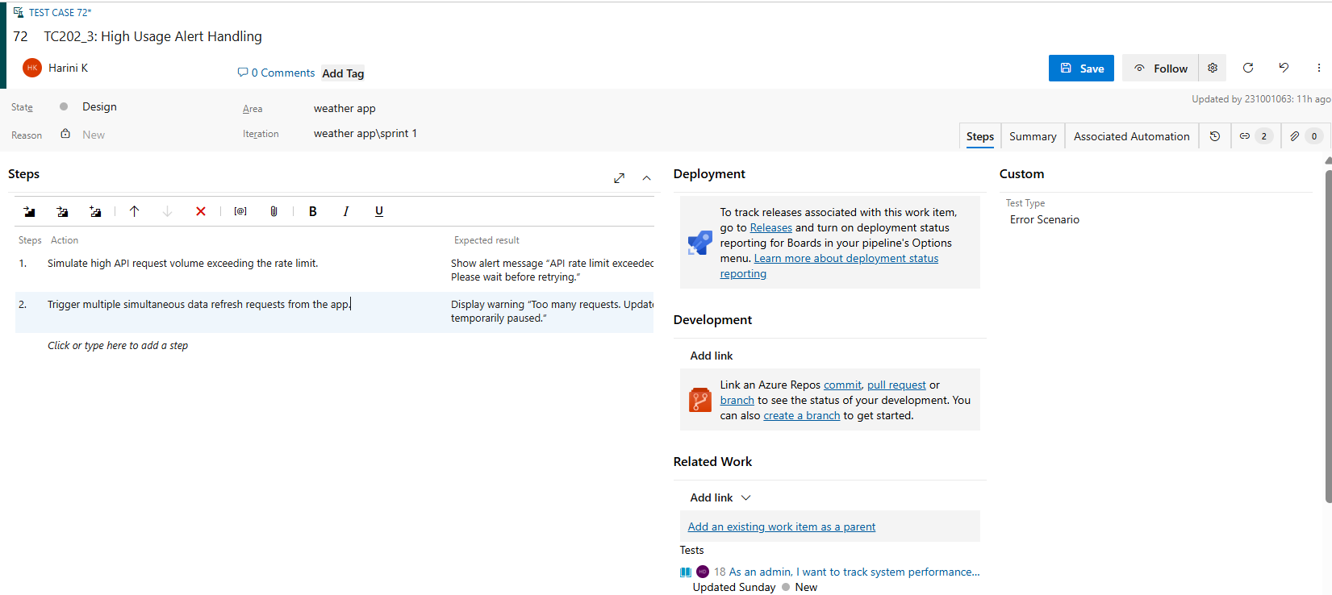

**4.Installation of test**

Test and feedback

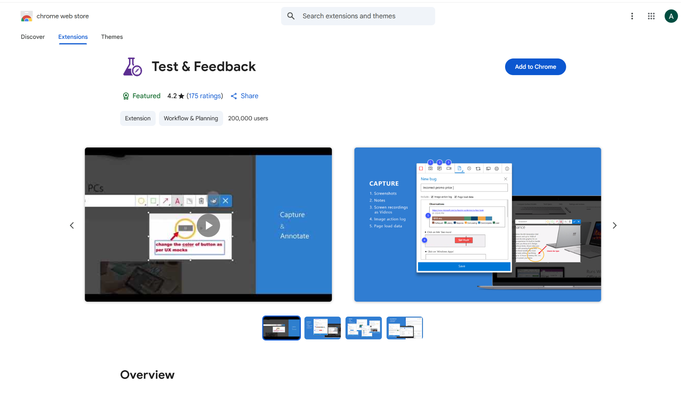

Showing it as an extension

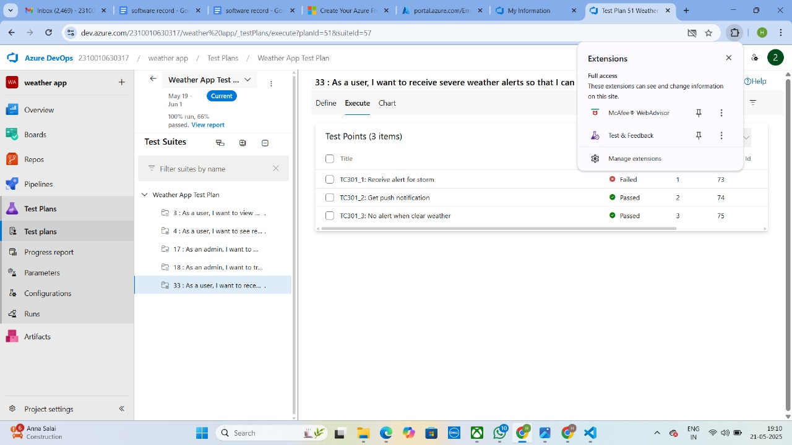

**5.Running the test cases**

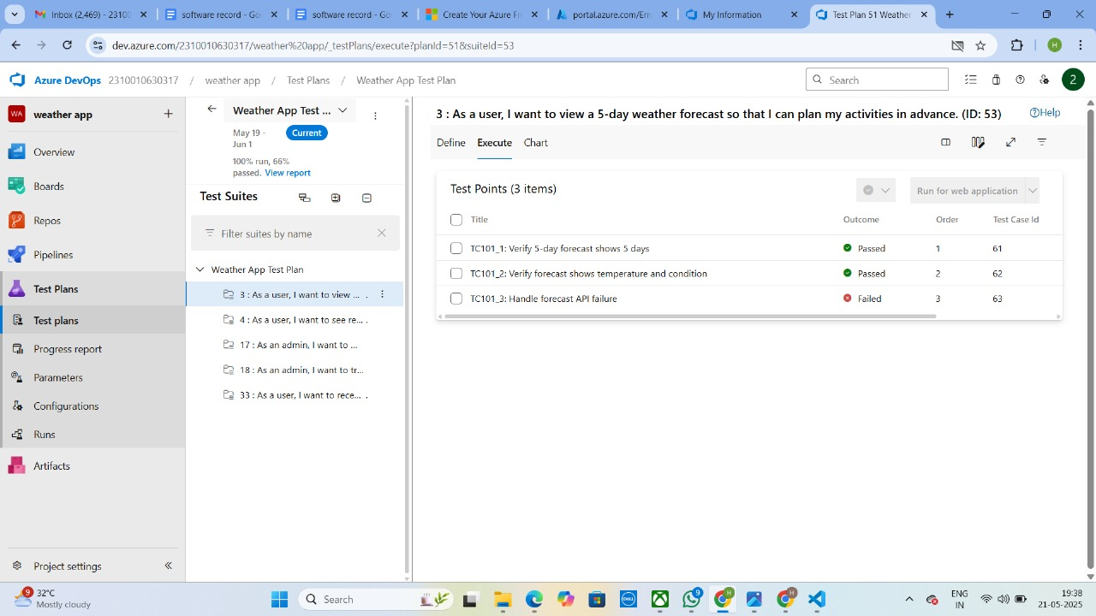

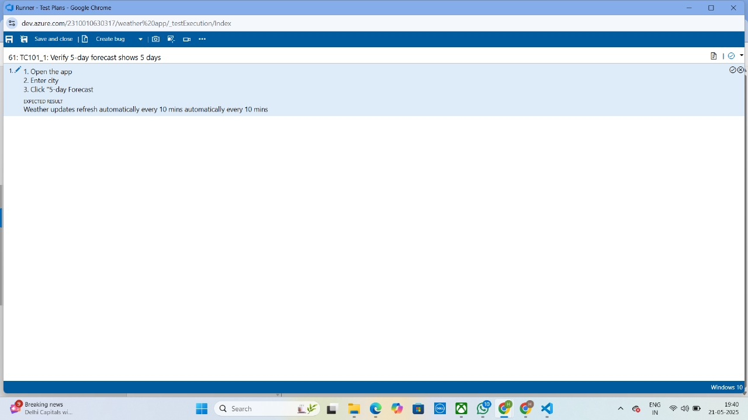

**6.Recording the test case**

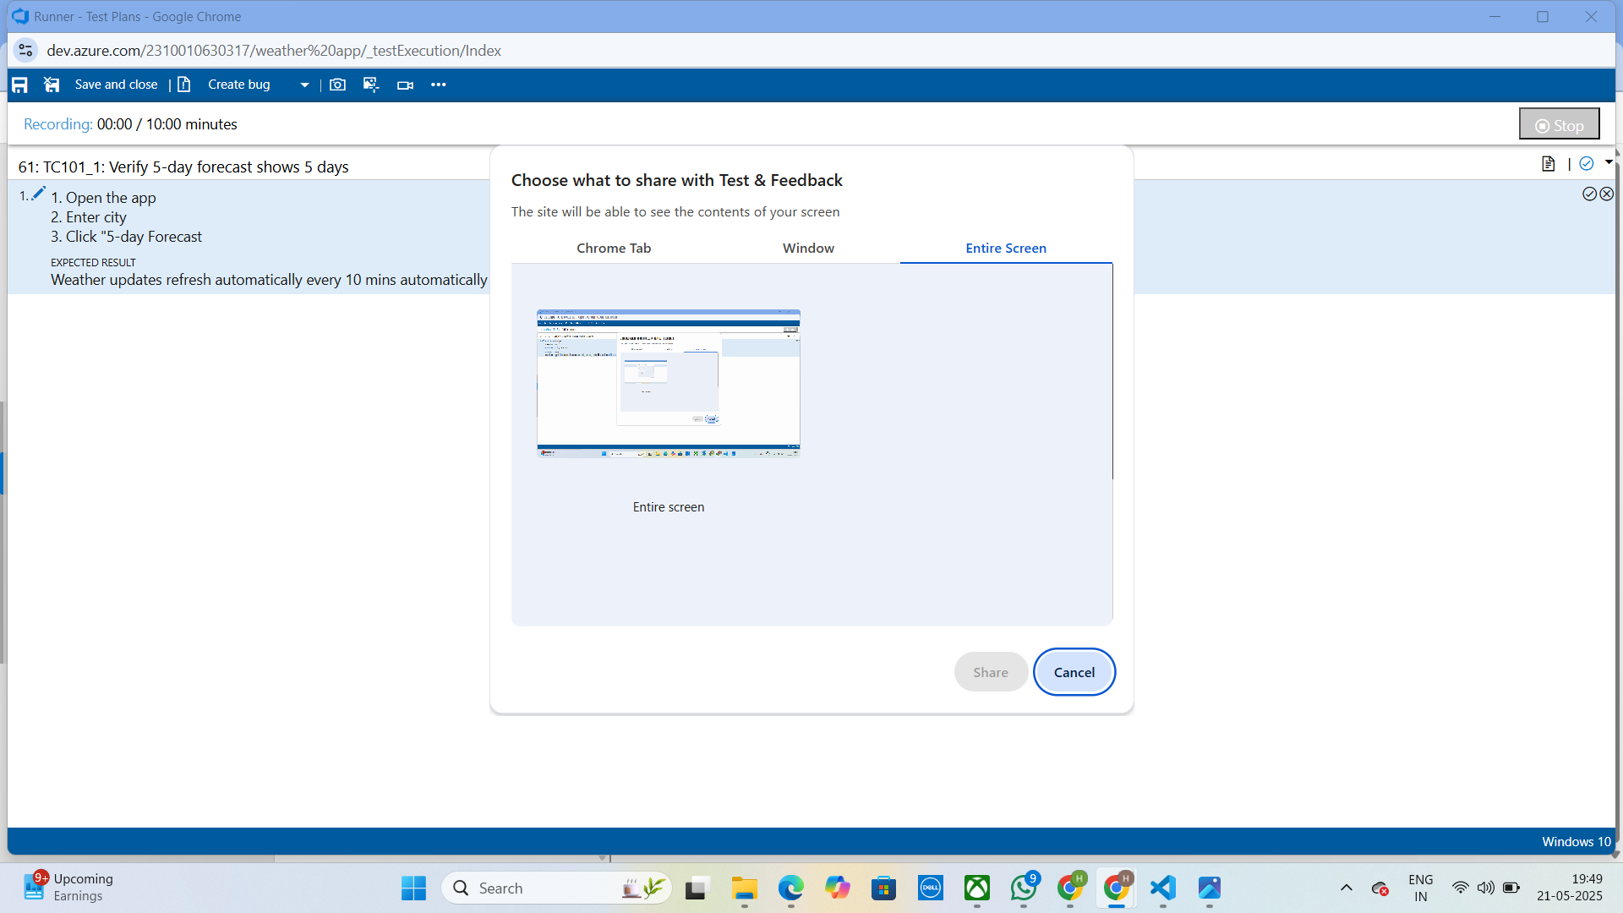

**7.Creating the bug**

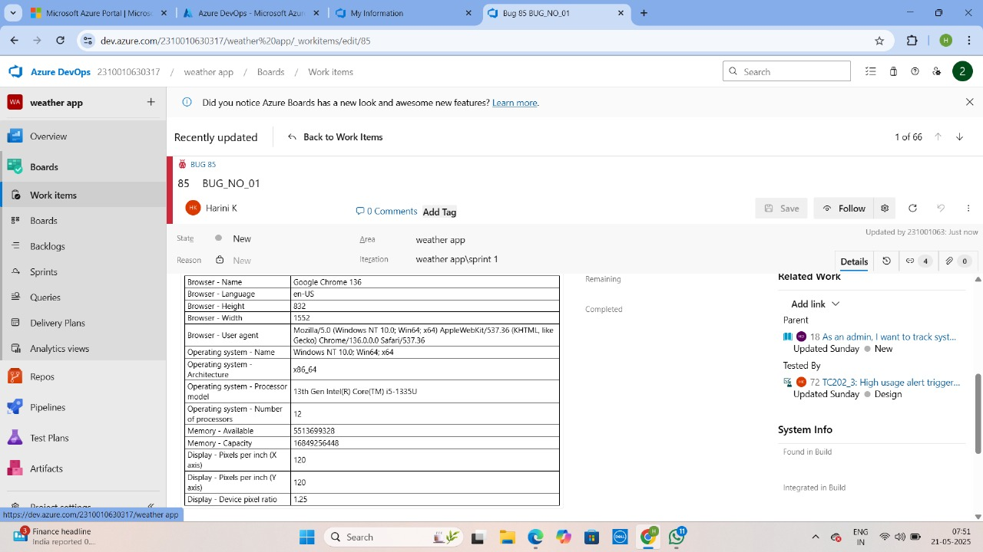

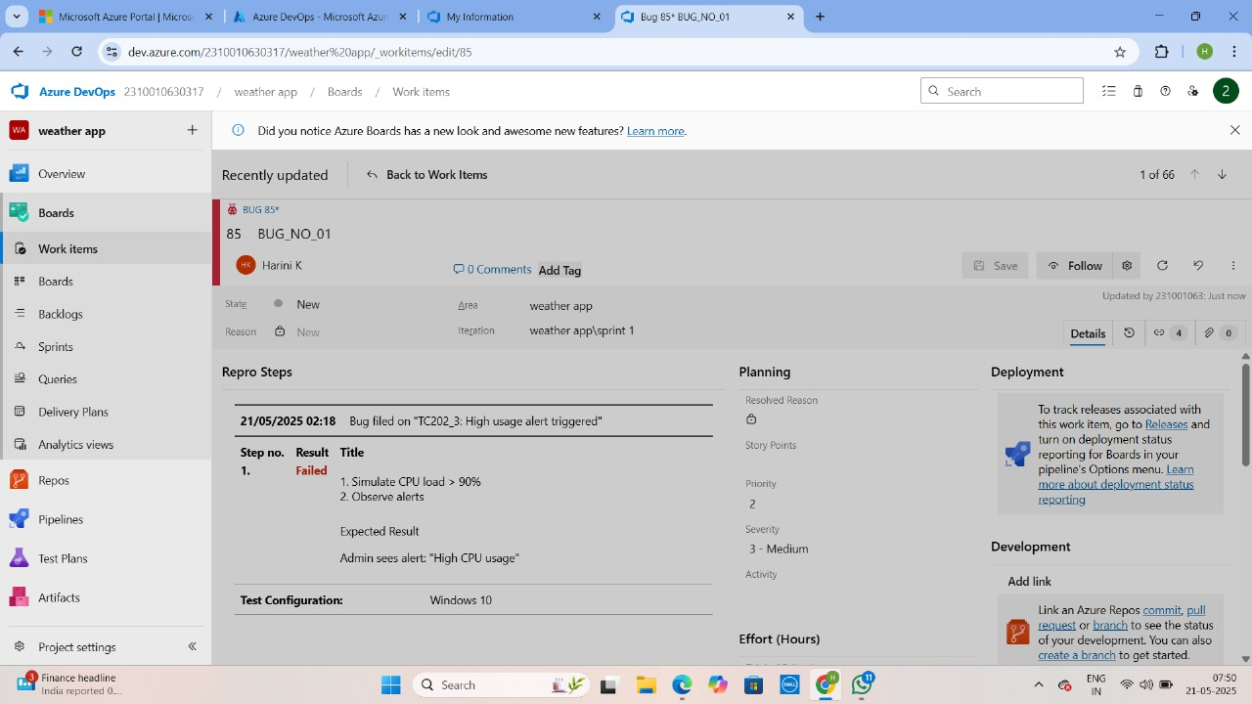

**8.Test case results**

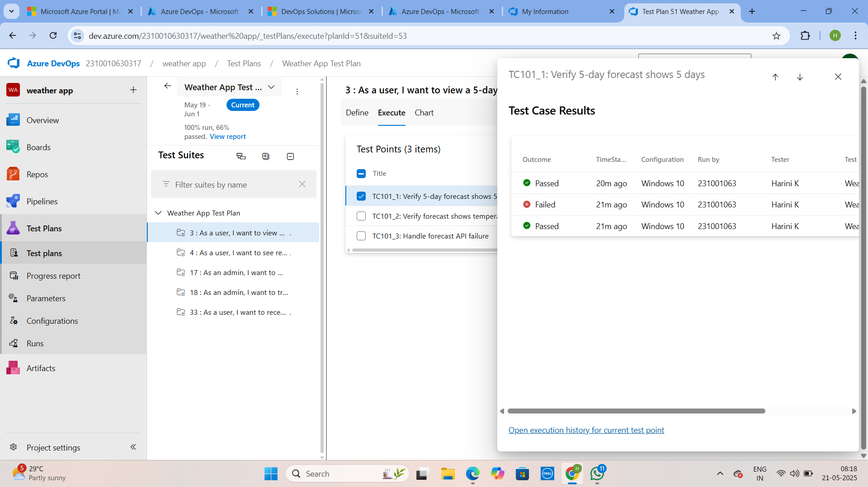

**9.Test report summary**

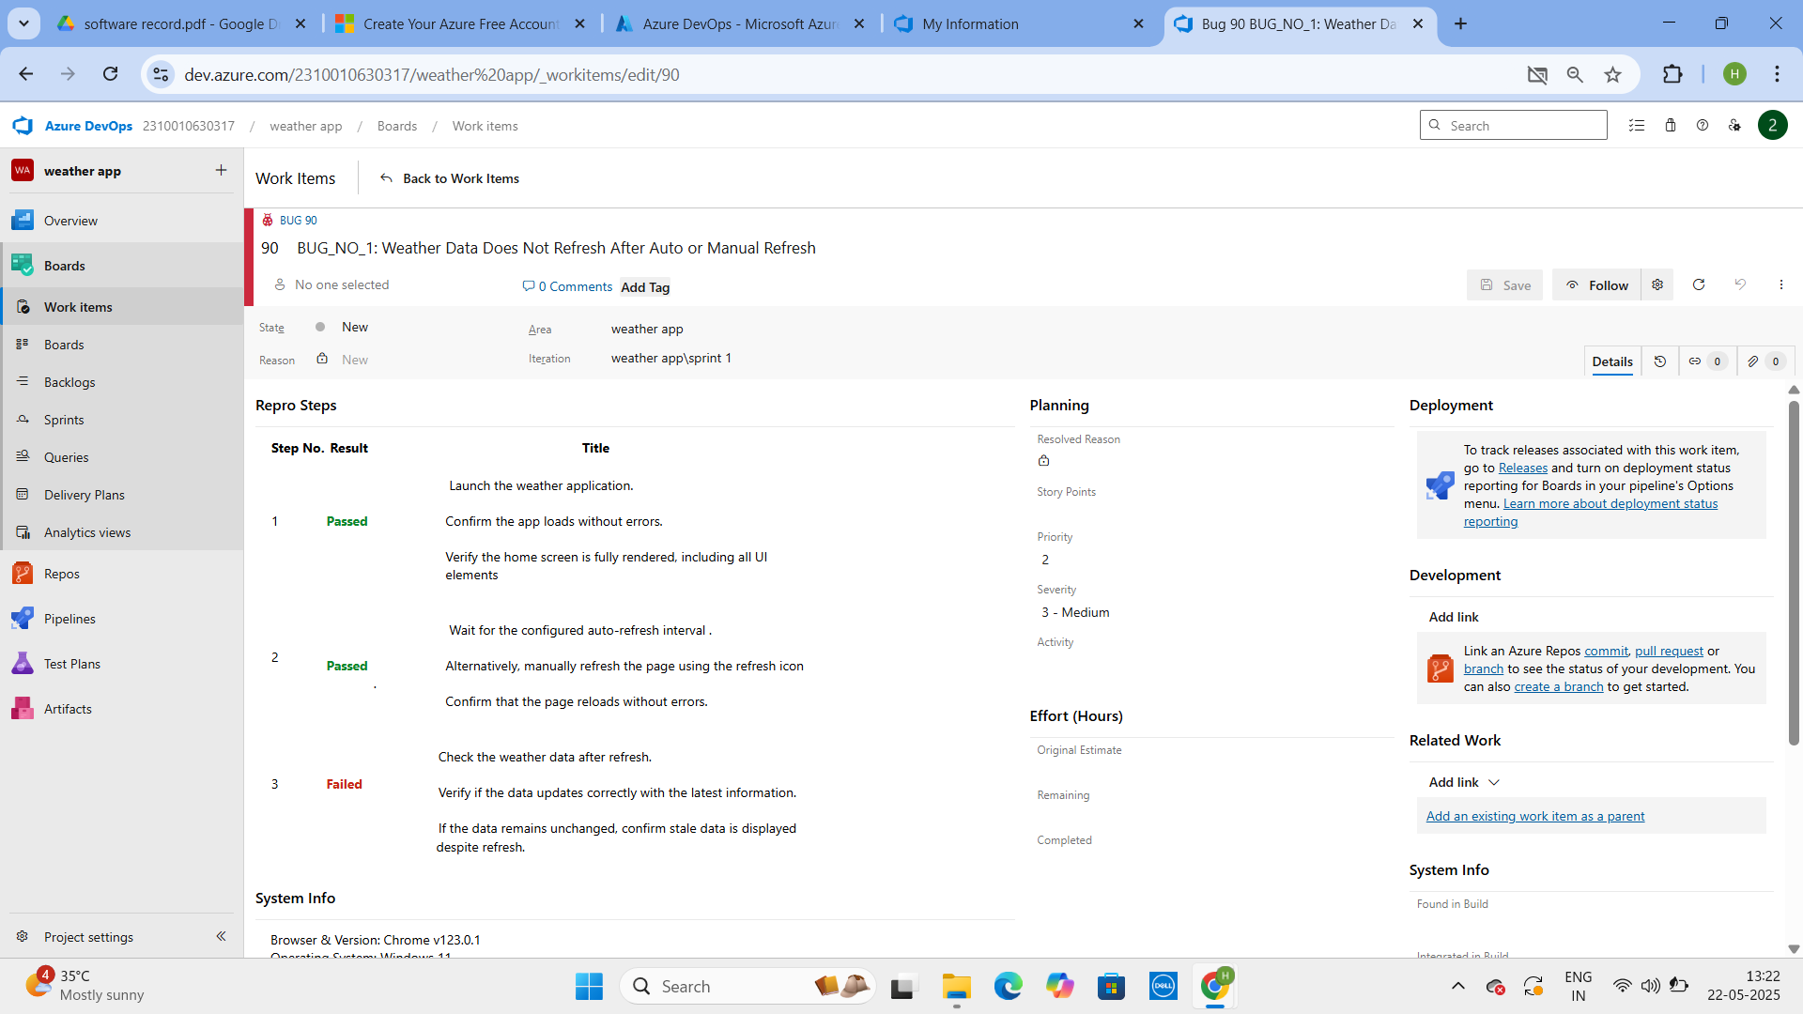

• Assigning bug to the developer and changing state

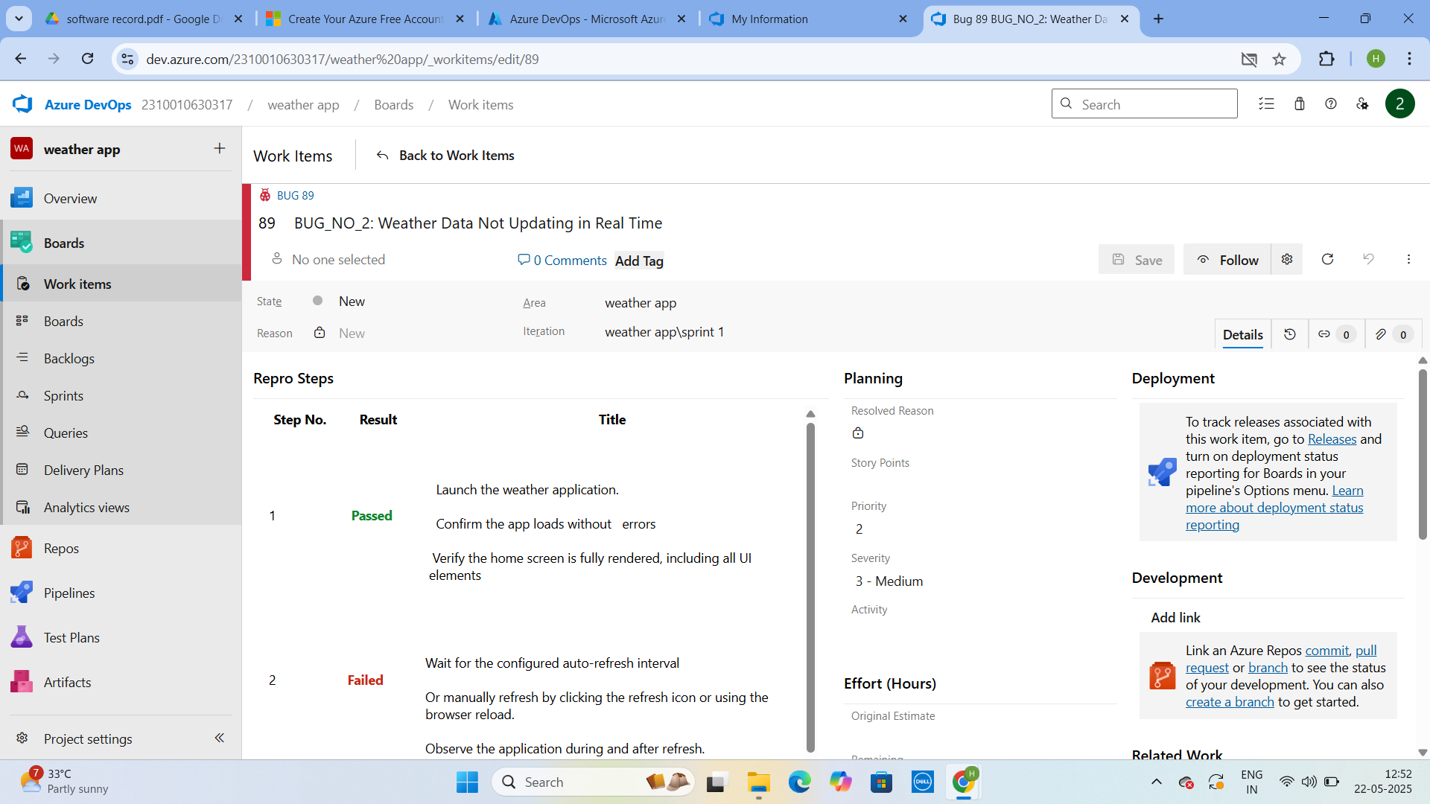

**10.Progress report**

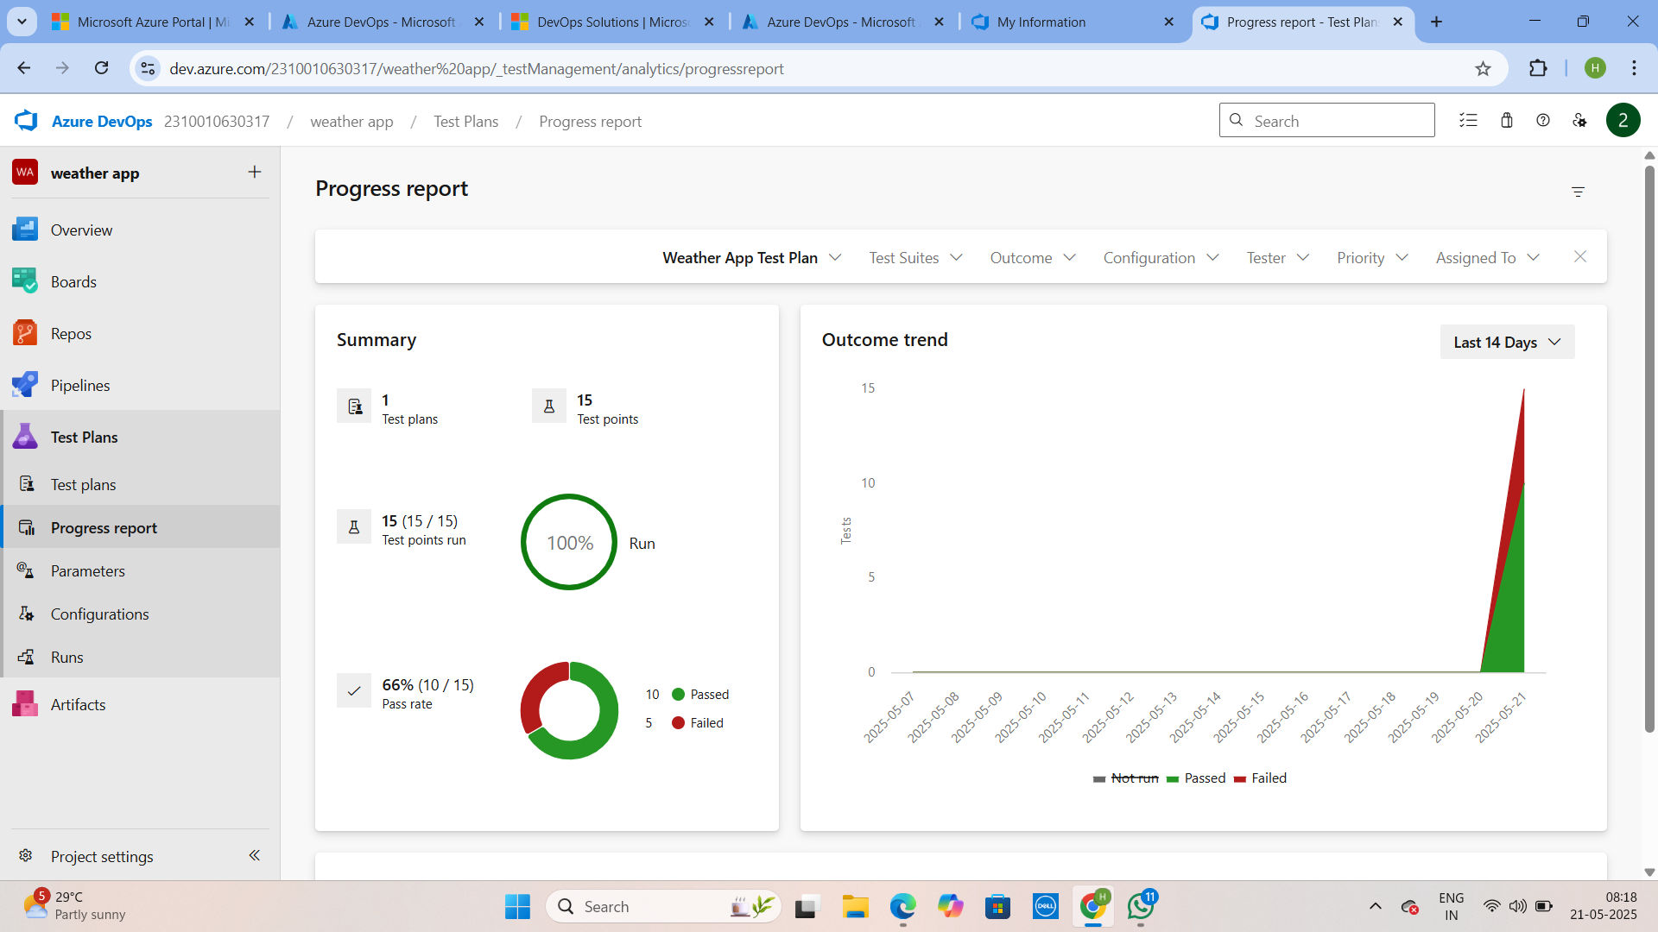



**11.Changing the test template**

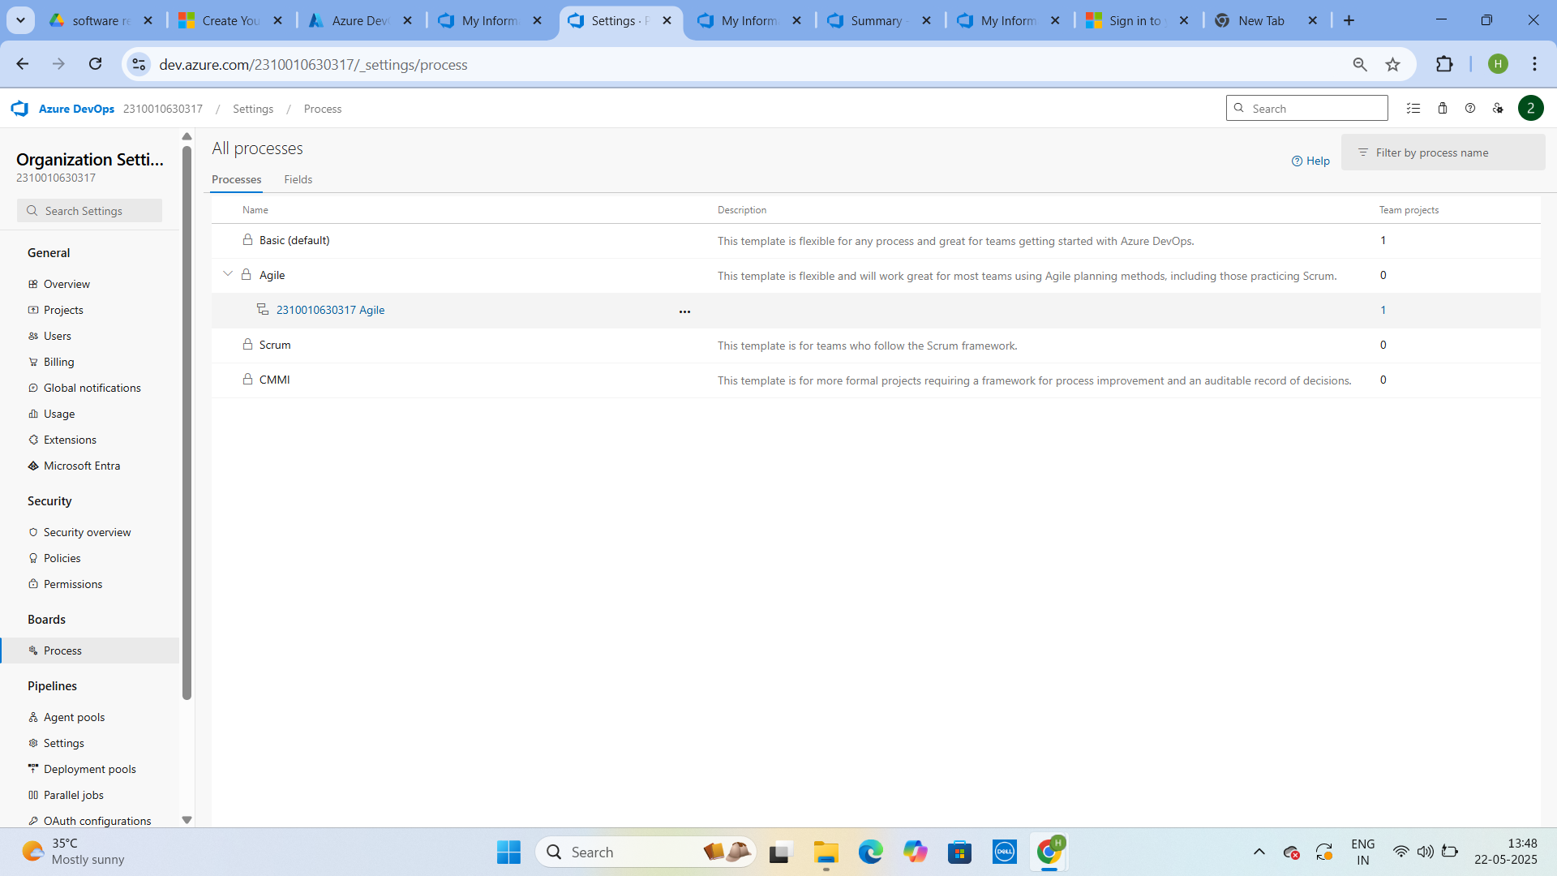

**12.View the new test case template**

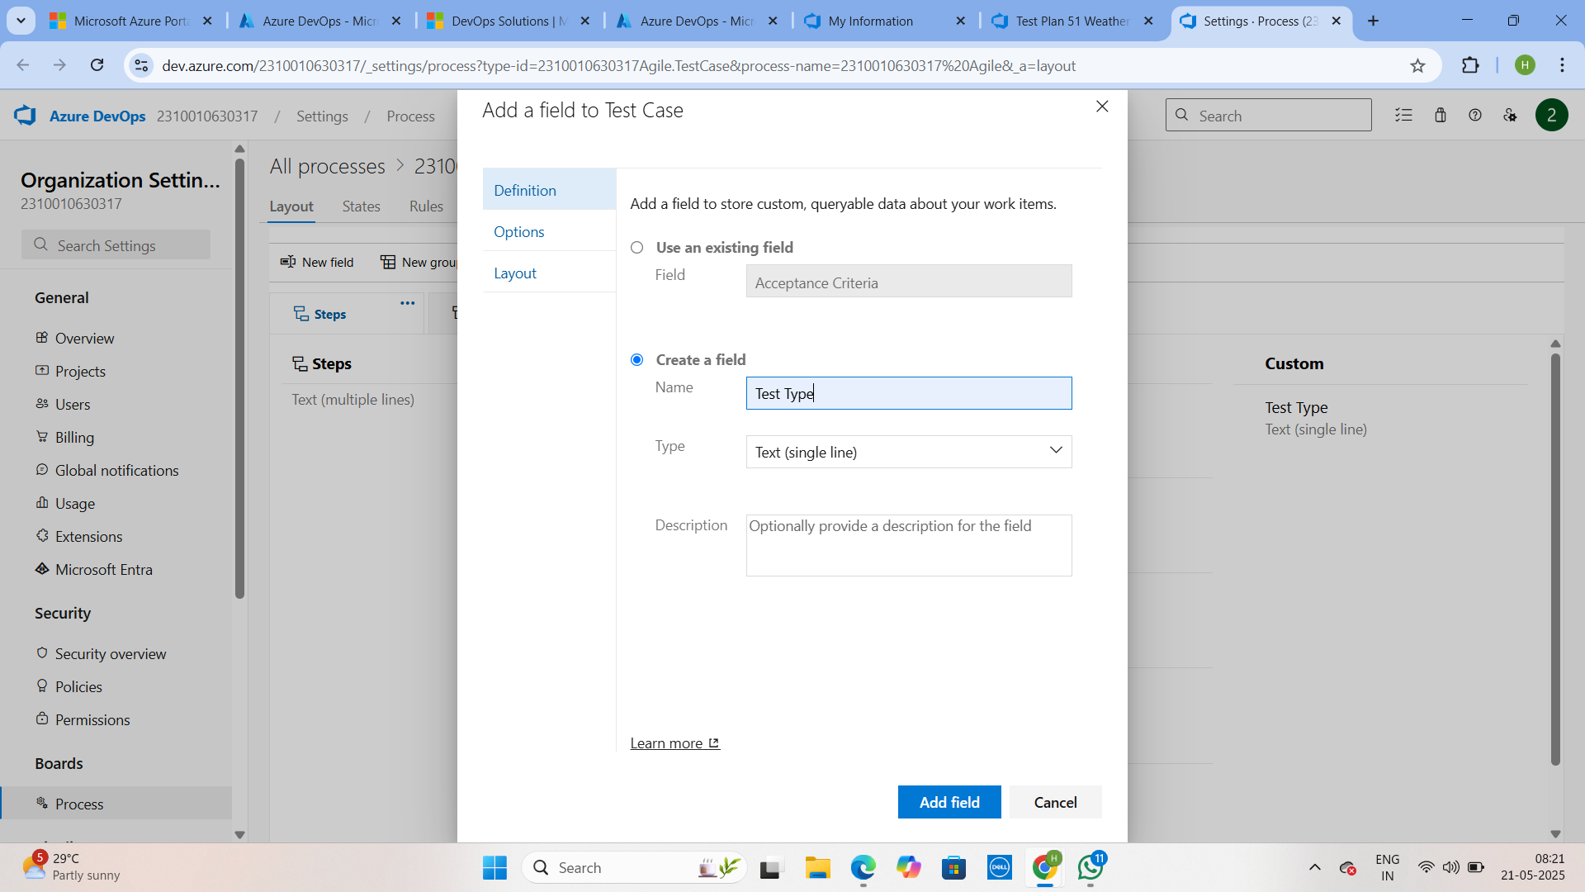

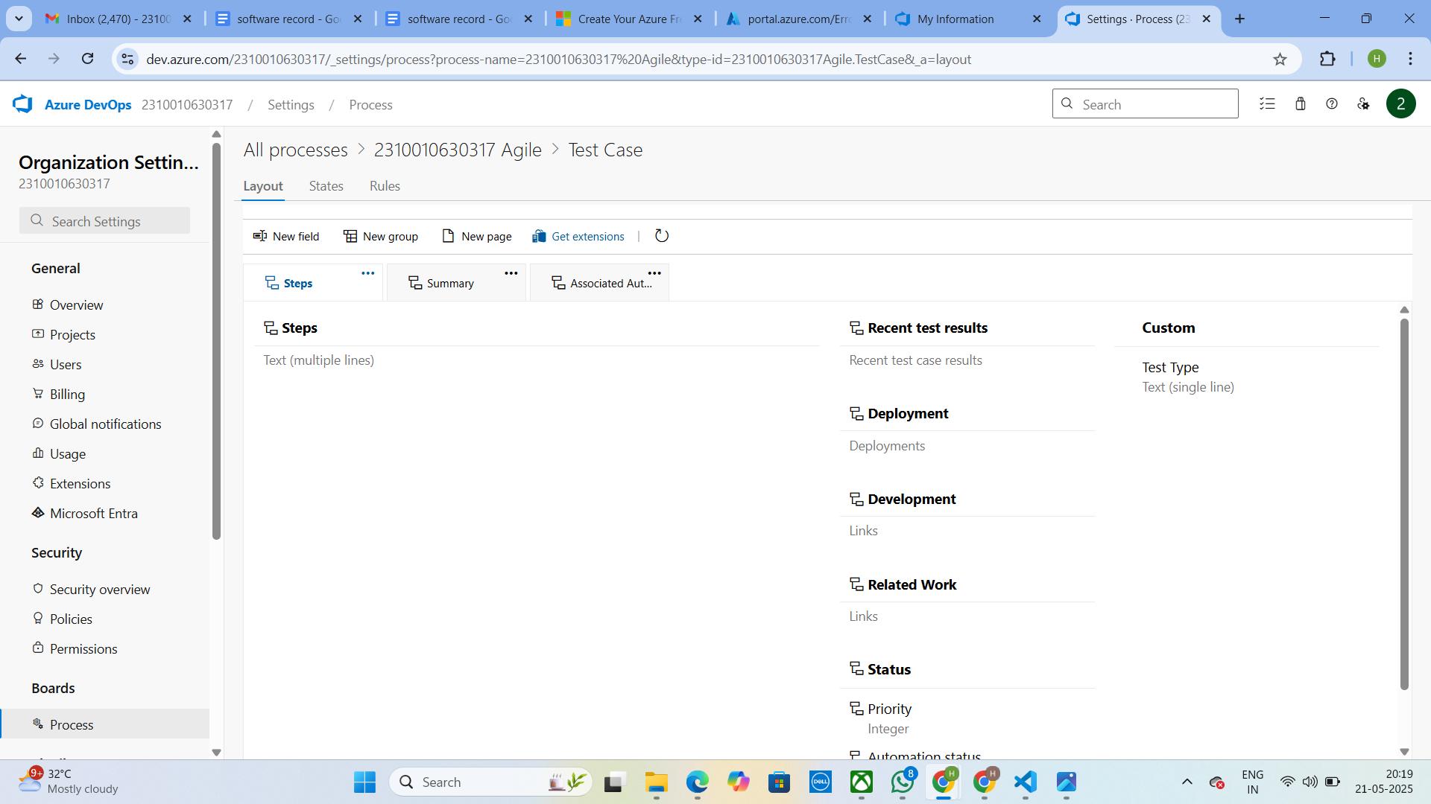

**RESULT:** The test plans and test cases for the user stories is created in Azure DevOps with Happy Path and Error Path

|  |  |
| --- | --- |
| **Exp.No: 9** | **LOAD TESTING AND PERFORMANCE TESTING** |
| **Date: 25/04/2025** |

**AIM:** To create an Azure Load Testing resource and run a load test to evaluate the performance of a target endpoint.

**LOAD TESTING**

**Steps to Create an Azure Load Testing Resource:**

Before you run your first test, you need to create the Azure Load Testing resource: 1. Sign in to Azure Portal

Go to https://portal.azure.com and log in.

2. Create the Resource o Go to *Create a resource* → Search for “Azure Load Testing”. o Select Azure Load Testing and click Create.

3. Fill in the Configuration Details

o Subscriptio*n:* Choose your Azure subscription

o *Resource Group:* Create new or select an existing one.

o *Name:* Provide a unique name (no special characters).

o *Location:* Choose the region for hosting the resource.

4. (Optional) Configure tags for categorization and billing.

5. Click Review + Create, then Create.

6. Once deployment is complete, click Go to resource.

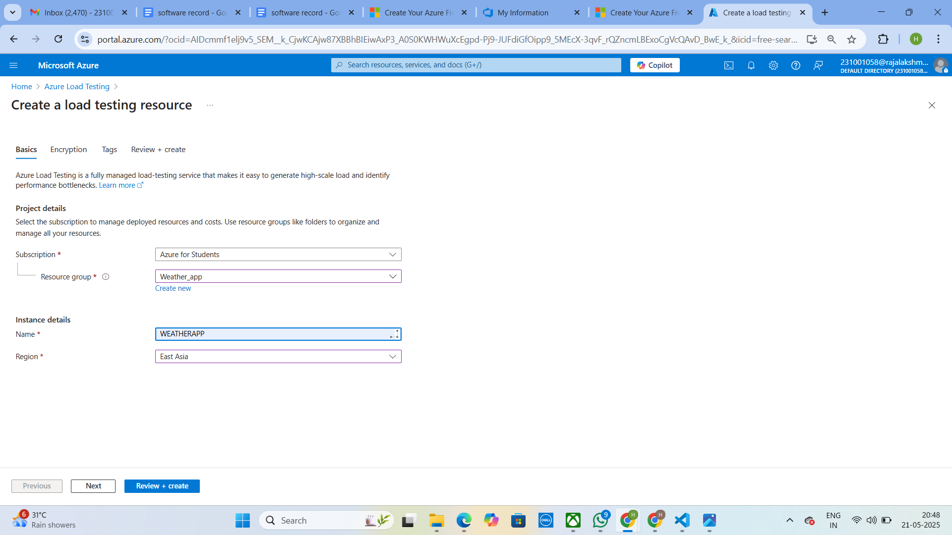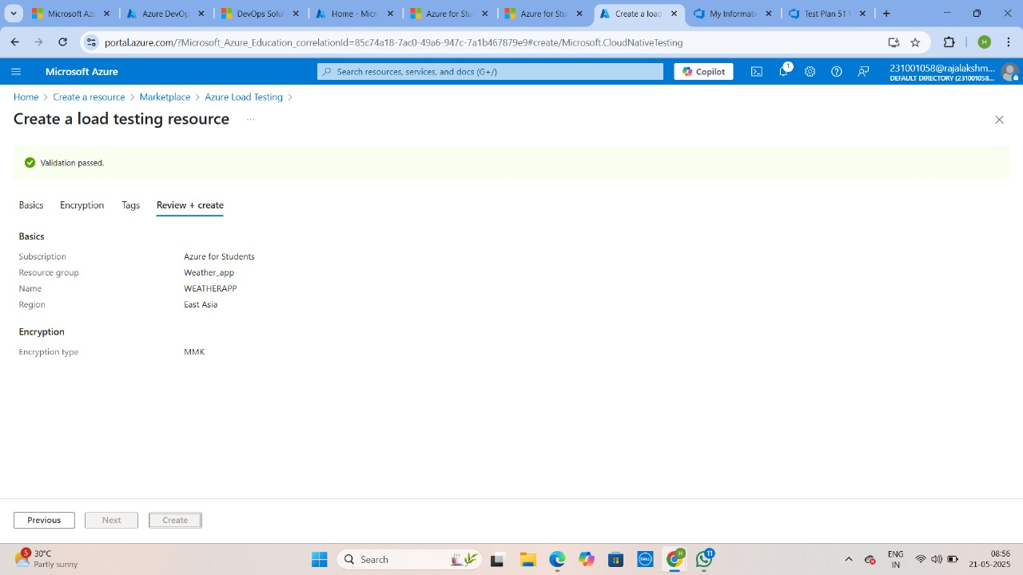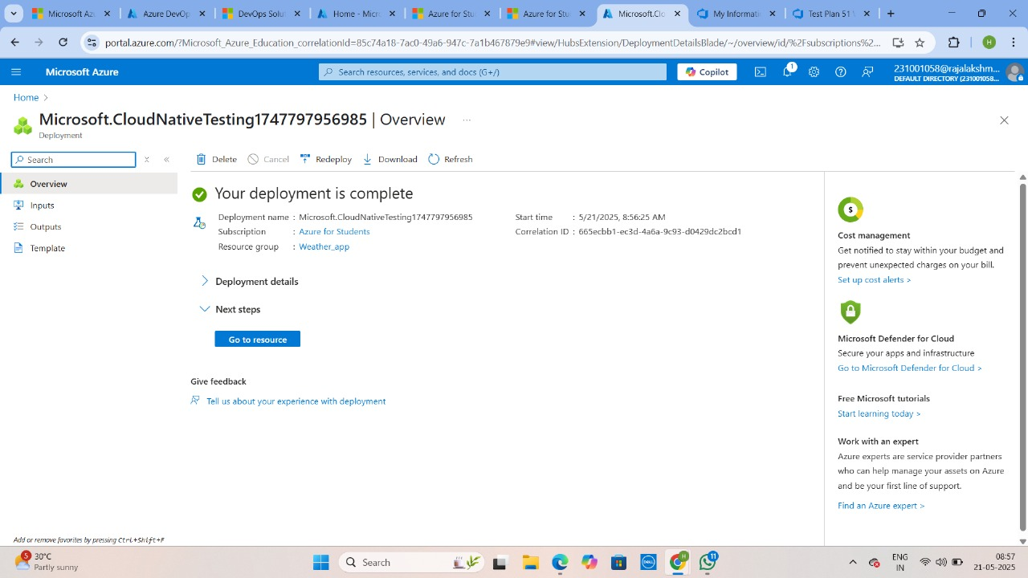

**Steps to Create and Run a Load Test:**

Once your resource is ready:

1. Go to your Azure Load Testing resource and click Add HTTP requests > Create. 2. Basics Tab o *Test Name:* Provide a unique name.

o *Description:* (Optional) Add test purpose.

o *Run After Creation:* Keep checked.

3. Load Settings o *Test URL:* Enter the target endpoint (e.g., https://yourapi.com/products). 4. Click Review + Create → Create to start the test.

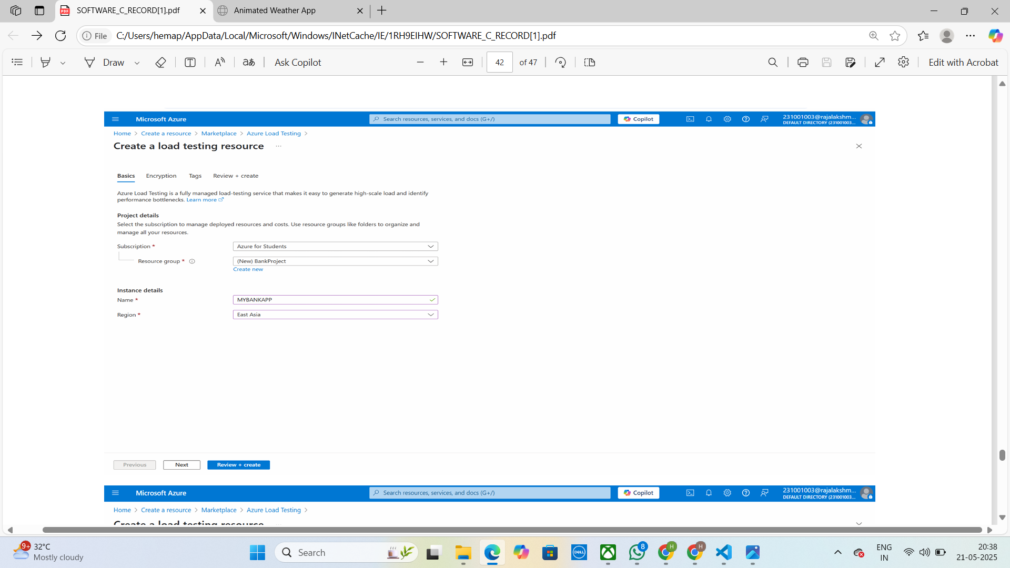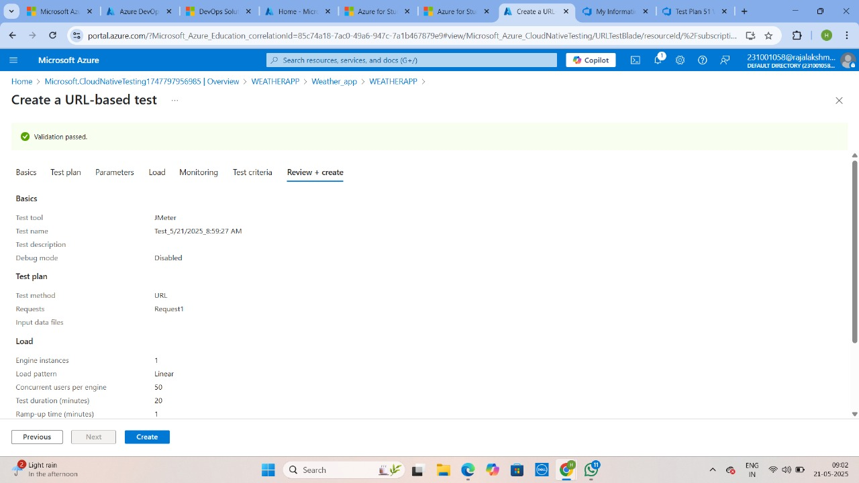

**Load Testing**

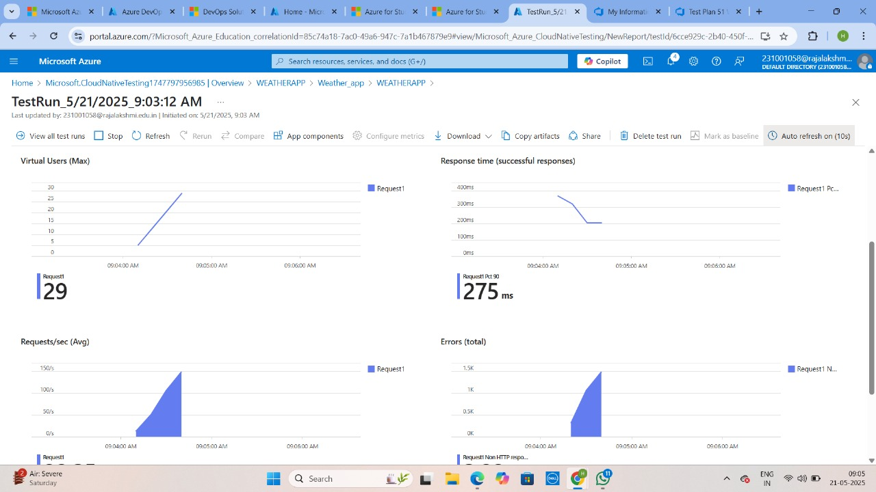

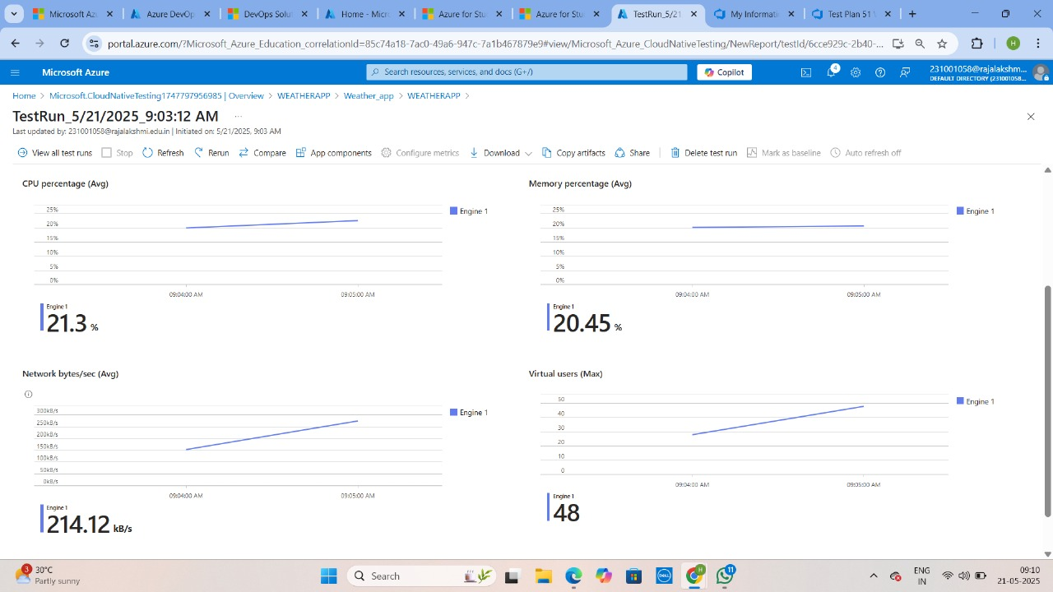

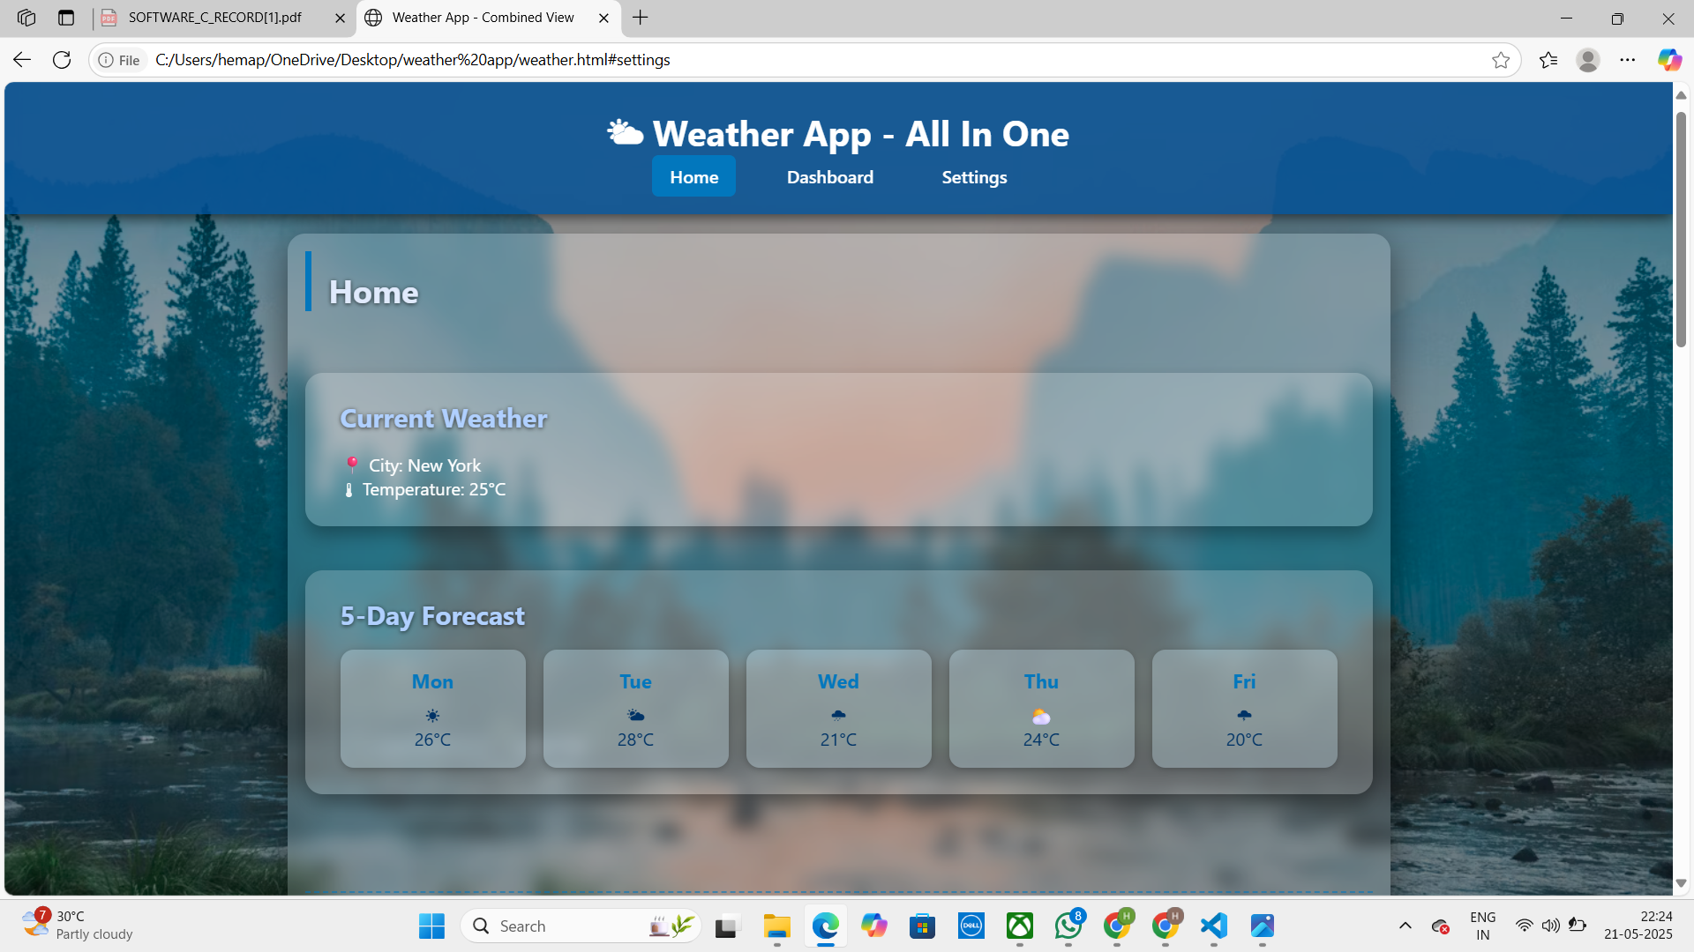

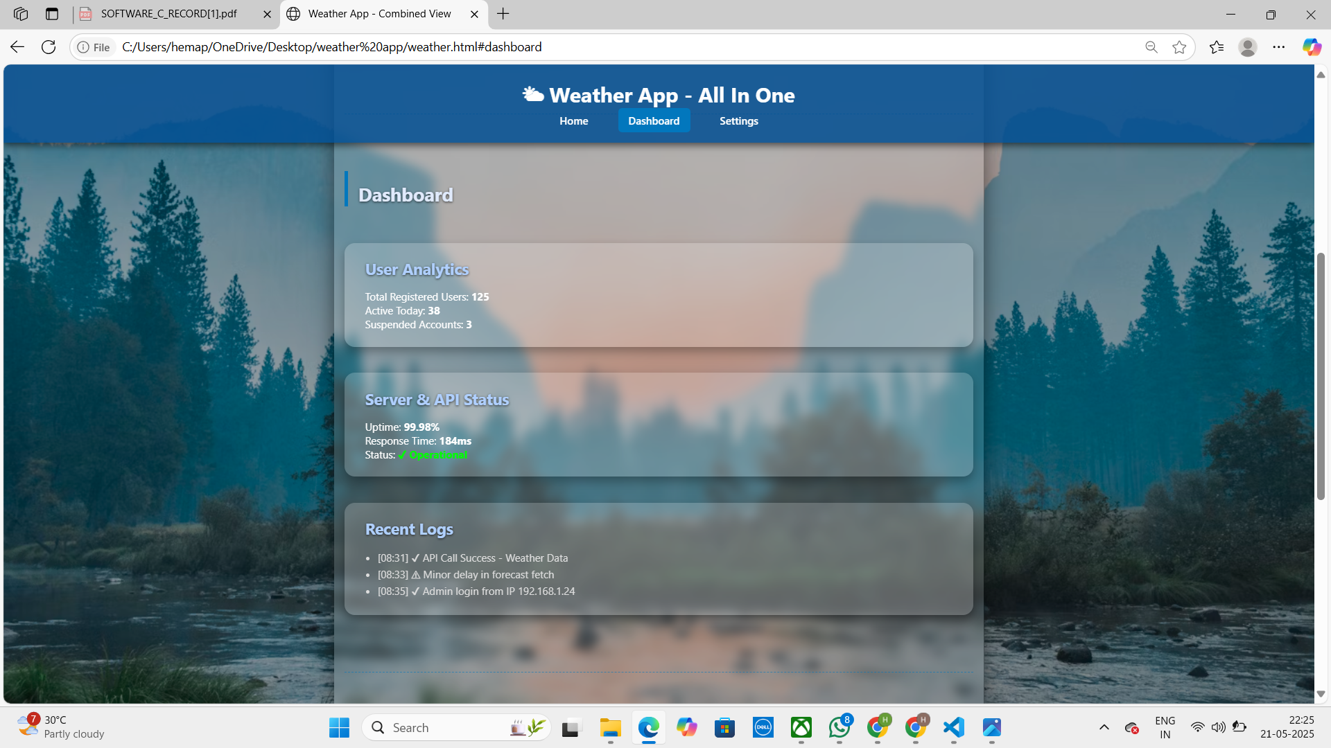

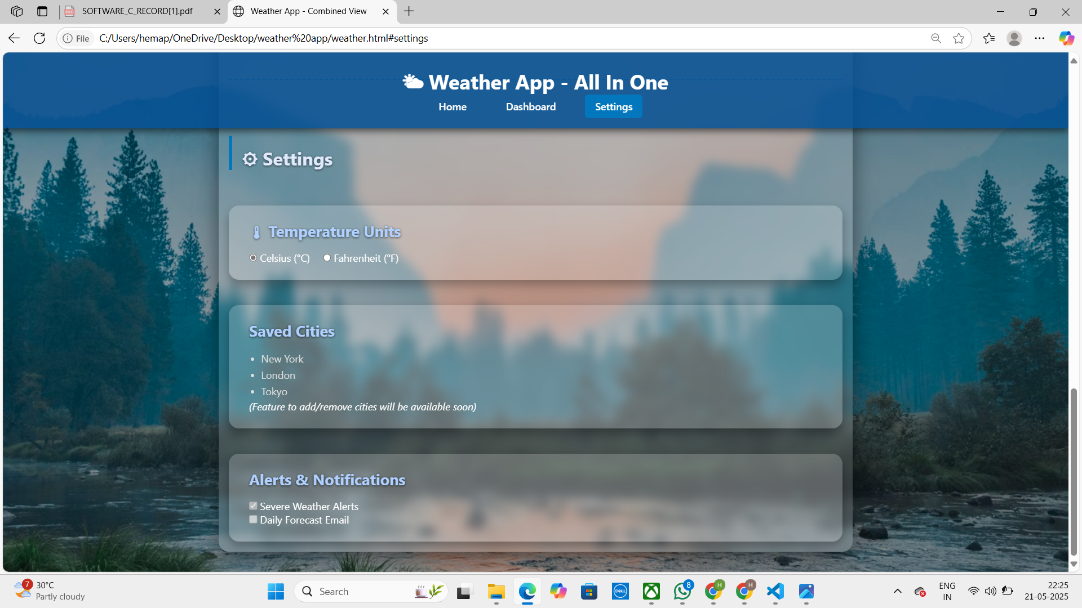

**RESULT:** Successfully created the Azure Load Testing resource and executed a load test to assess the performance of the specified endpoint.

|  |  |
| --- | --- |
| **Exp.No: 10** | **GITHUB PROJECT STRUCTURE & NAMING**  **CONVENTIONS** |
| **D ate: 02/05/2025** |

**AIM:** To provide a clear and organized view of the project's folder structure and file naming conventions, helping contributors and users easily understand, navigate, and extend the Weather App project.

**GITHUB PROJECT STRUCTURE**

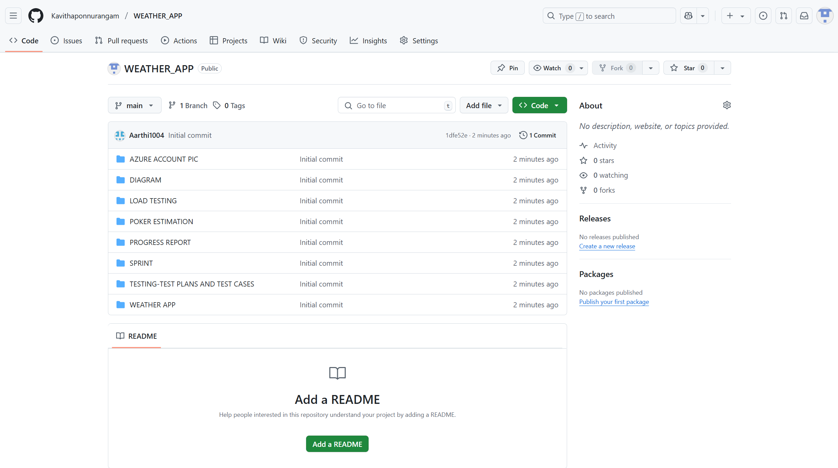

**RESULT:** The GitHub repository clearly displays the organized project structure and consistent naming conventions, making it easy for users and contributors to understand and navigate the codebase.